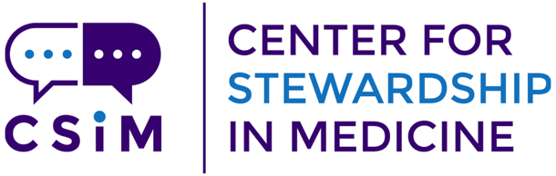
DRAFT 2026 Annual Conference
September 25, 2026 Agenda
Spokane, WA

Time Session

8 AM | Registration opens (hot breakfast served)
9 – 9:30 AM | UW CSiM Year in Review
9:30 – 10:20 AM | Keynote Speaker
10:20 – 10:30 AM | Break
10:30 – 11:20 AM | Andre M. Gouws Memorial Lecture in Infectious Disease Pharmacy:  by Whitney Buckel, PharmD
11:20 – 11:30 AM | Break
11:30 AM – 12:15 PM | Workshop 1*
12:15 – 1:15 PM | Lunch (buffet lunch offered)
1:15 – 2 PM | Workshop 2*
2 – 2:10 PM | Break
2:10 – 3:05 PM | Workshop 3*
3:05 – 4 PM | Wrap up

*Workshop Options to be determined

The Andre M. Gouws Memorial Lecture in Infectious Disease Pharmacy honors Dr. Andre Gouws, PharmD, a champion of rural medicine and antibiotic stewardship, and dedicated member of the Center for Stewardship in Medicine family. This annual lecture in his memory seeks to bring experts in the field of pharmacy and stewardship to enrich and strengthen the stewardship community.

