Coulee IQIC 101 Asymptomatic Bacteriuria (ASB) Baseline Report

February 2023

|  |  |
| --- | --- |
| Prevalence of ASB at Coulee (11 of 50) = 22% | Treatment Rate of ASB at Coulee (9 of 11) = 82% |

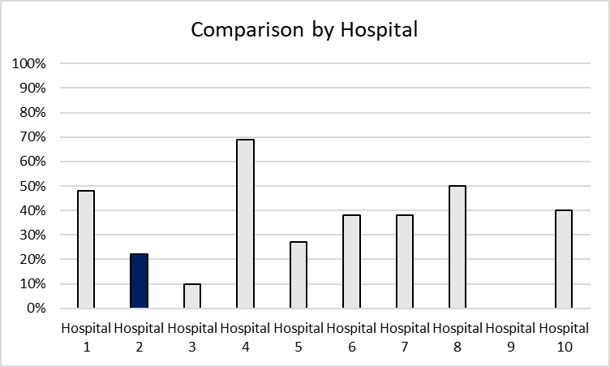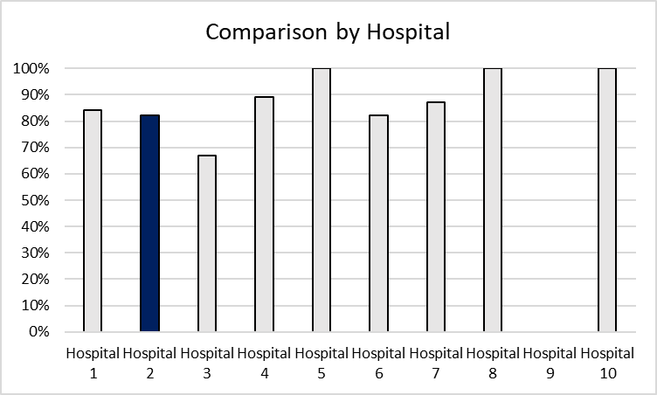

**Number of total cases included from Coulee: 467**

**Number of total positive urine cultures from Coulee: 78**

**Number of total cases included in overall population: 467**

**Number of total positive urine cultures in overall population: 224**

**Prevalence of ASB in overall cohort (87 of 224) = 39%**

**Treatment rate of ASB in overall cohort (75 of 87) = 86%**

|  |  |  |  |  |
| --- | --- | --- | --- | --- |
| Antibiotic Selection, n (%) | IV | | PO | |
|  | Total cases, n=78 | ASB, n=9 | Total cases, n=78 | ASB, n=9 |
| Antibiotic 1 | Ceftriaxone, 7 (9) | Ceftriaxone, 3 (33) | Nitrofurantoin, 23 (29) | Nitrofurantoin, 3 (33) |
| Antibiotic 2 | Amp/sul, 1 (1) | Amp/sul, 1 (11) | TMP/SMX, 12 (15) | TMP/SMX, 2 (22) |
| Antibiotic 3 | --- | --- | Ciprofloxacin, 5 (6) | Levofloxacin, 1 (11) |
| Antibiotic 4 | --- | --- | Cephalexin, 3 (4) | Amox/clav, 1 (11) |
| Antibiotic 5 | --- | --- | Levofloxacin, 3 (4) | Amoxicillin, 1 (11) |

|  |  |  |
| --- | --- | --- |
| Antibiotic Duration | Total cases, n=78 | ASB, n=9 |
| Total Antibiotic Duration; median (IQR) | 7 days (1-8) | 8 days (7-10) |
| Number of Cases Receiving >7 days; n (%) | 21 (27) | 5 (56) |

|  |  |  |
| --- | --- | --- |
| Characteristics; n (%) | Total cases, n=78 | Treated ASB, n=9 |
| Setting |  |  |
| ED, then admitted | 3 (4) | 1 (11) |
| ED, then discharged | 30 (38) | 5 (56) |
| Other | 45 (58) | 3 (33) |
| From reflex test | 26 (33) | 8 (89) |
| Men | 16 (21) | 6 (67) |
| Age, median y | 65 | 65 |
| Chronic catheter use | 5 (6) | 2 (22) |
| Chronic urinary retention | 4 (5) | 1 (11) |
| Altered mental status | 1 (1) | 1 (11) |

**Key and Definitions**:

* Positive urine culture: urine culture showing ≥100,000 CFU/mL of one or more bacteria. Includes ≥100,000 CFU/mL of mixed flora.
* Prevalence of ASB: Positive urine culture showing ≥100,000 CFU/mL of one or more bacteria in the absence of signs or symptoms attributable to urinary tract infection (using various definitions below). Includes ≥100,000 CFU/mL of mixed flora.
  + Signs or symptoms of UTI includes:
    - Fever (>38°C)
    - Suprapubic tenderness
    - Costovertebral angle pain or tenderness
    - Urinary urgency
    - Urinary frequency
    - Dysuria
    - Hematuria
    - AMS PLUS a systemic sign of possible infection
      * Peripheral leukocytosis >10 000 cells/mm3
      * Systolic blood pressure <90 mm Hg
* Treatment rate of ASB: antibiotic treatment for ASB