Coulee IQIC 101 Asymptomatic Bacteriuria (ASB) Final Report

June 2023

|  |  |
| --- | --- |
| Prevalence of ASB at Coulee (32 of 95) = 34% | Treatment Rate of ASB at Coulee (27 of 32) = 84% |

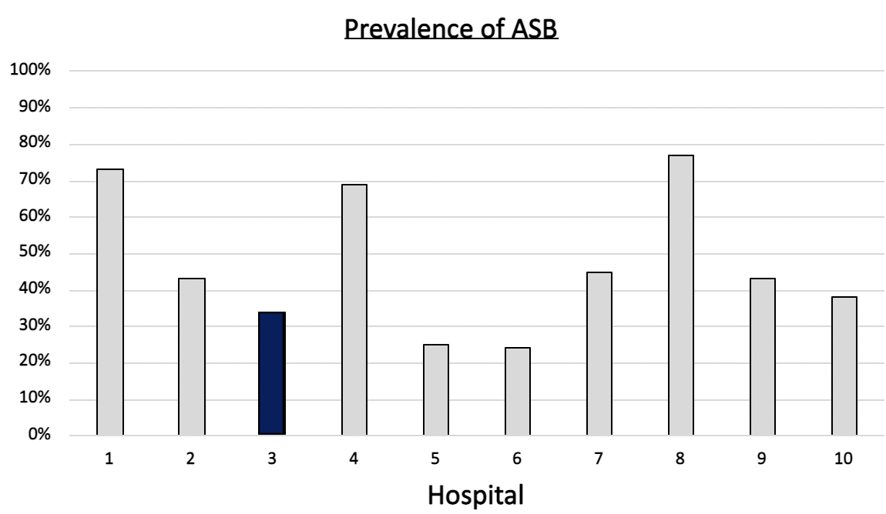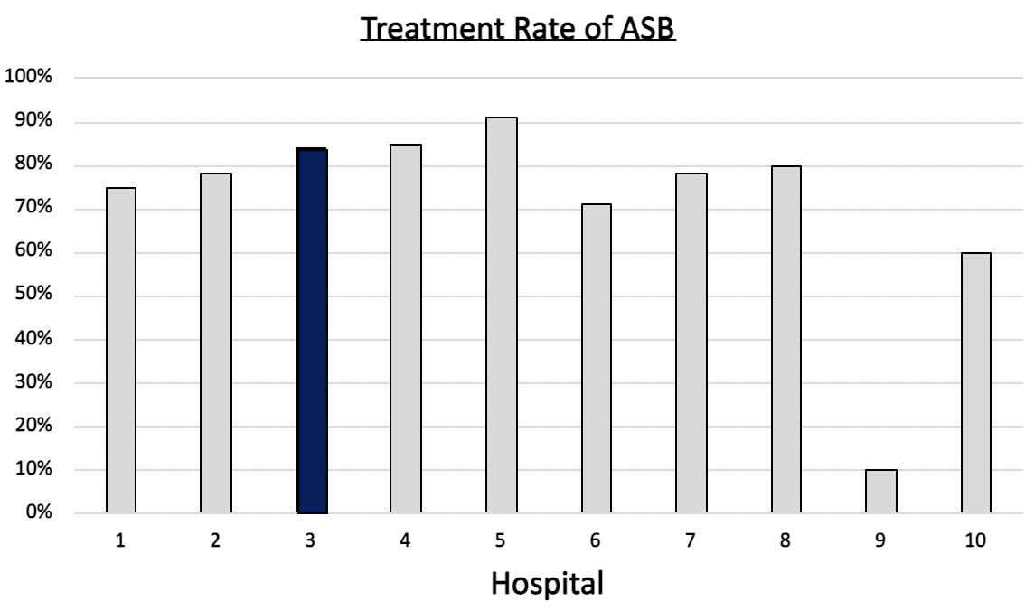

**Number of total cases submitted from Coulee: 142**

**Number of total cases included from Coulee: 122**

**Number of total positive urine cultures from Coulee: 95**

**Number of total positive urine cultures in overall population: 672**

**Prevalence of ASB in overall cohort (264 of 672) = 39%**

**Treatment rate of ASB in overall cohort (210 of 264) = 80%**

|  |  |  |  |  |
| --- | --- | --- | --- | --- |
| Antibiotic Selection, n (%) | IV | | PO | |
|  | Total cases, n=142 | ASB, n=27 | Total cases, n=142 | ASB, n=27 |
| Antibiotic 1 | Ceftriaxone, 17 (12) | Ceftriaxone, 3 (11) | Nitrofurantoin, 53 (37) | Nitrofurantoin, 12 (44) |
| Antibiotic 2 | Pip/tazo, 2 (1) | Cefazolin, 2 (7) | TMP/SMX, 23 (16) | TMP/SMX, 6 (22) |
| Antibiotic 3 | Amp/sul, 1 (0.7) | Pip/tazo, 1 (4) | Ciprofloxacin, 6 (4) | Amoxicillin, Amox/clav, cefdinir, cephalexin, fosfomycin, levofloxacin, 1 (4) |
| Antibiotic 4 | Levofloxacin, 1 (0.7) | --- | Cephalexin, 6 (4) |
| Antibiotic 5 | --- | --- | Amox/Clav, 4 (3) |

|  |  |  |
| --- | --- | --- |
| Antibiotic Duration | Total cases, n=142 | ASB, n=27 |
| Total Antibiotic Duration; median (IQR) | 7 days (5-8.5) | 7 days (7-10) |
| Number of Cases Receiving >7 days; n (%) | 40 (28) | 13 (48) |

|  |  |  |
| --- | --- | --- |
| Characteristics; n (%) | Total cases, n=142 | Treated ASB, n=27 |
| Setting |  |  |
| Ambulatory care clinic | 70 (49) | 10 (37) |
| ED, then admitted | 6 (4) | 1 (4) |
| ED, then discharged | 55 (39) | 12 (44) |
| Inpatient | 7 (5) | 2 (7) |
| Other | 4 (3) | 2 (7) |
| From reflex test | 114 (80) | 21 (78) |
| Men | 28 (20) | 12 (44) |
| Age, median y | 67 | 76 |
| Chronic catheter use | 6 (4) | 4 (15) |
| Chronic urinary retention | 5 (4) | 1 (4) |
| Altered mental status | 2 (1) | 1 () |

**Key and Definitions**:

* Positive urine culture: Any growth on culture.
* Prevalence of ASB: A positive urine culture without any documented signs or symptoms attributable to urinary tract infection per National Hospital Safety Network (NHSN) and Infectious Diseases Society of America (IDSA) Guidelines.
  + Signs or symptoms of UTI includes:
    - Fever (>38°C)
    - Suprapubic tenderness
    - Costovertebral angle pain or tenderness
    - Urinary urgency
    - Urinary frequency
    - Dysuria
    - Hematuria
    - AMS PLUS a systemic sign of possible infection
      * Peripheral leukocytosis >10 000 cells/mm3
      * Systolic blood pressure <90 mm Hg
* Treatment rate of ASB: antibiotic treatment for ASB

Coulee IQIC 101 Asymptomatic Bacteriuria (ASB) Final Report

June 2023

Percentage of patients treated for UTI who actually had ASB, overtime (number of patients treated for ASB / number of patients treated for UTI + ASB)

* Baseline: 26%
* Peri-Intervention: 41%

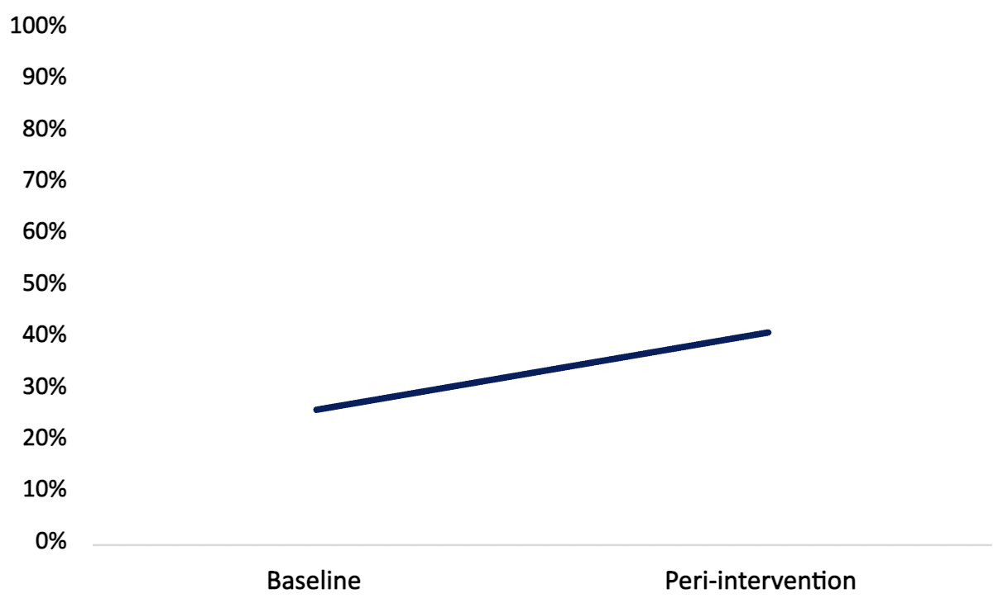

**Goal:** lower is better

**Why use?** You can lower the number by either reducing unnecessary urine cultures (**diagnostic stewardship**) or reducing antibiotic treatment when unnecessary cultures are obtained (**antibiotic stewardship**)