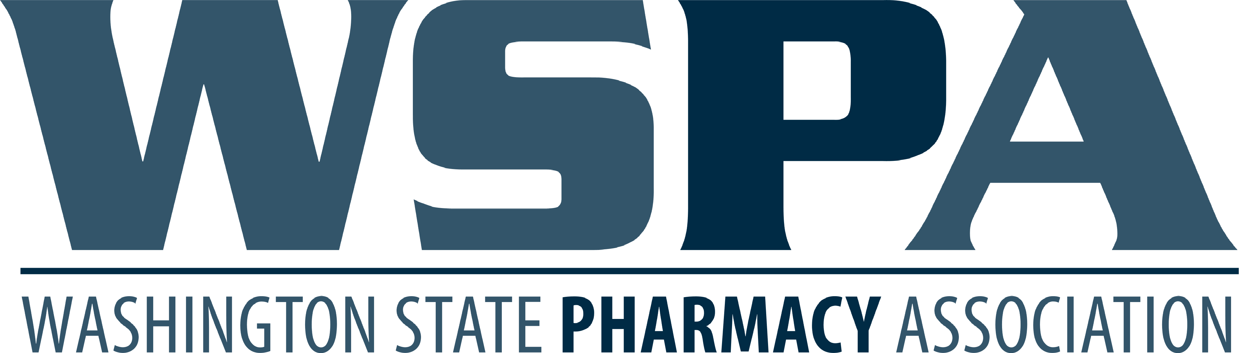

UW Tele-Antimicrobial Stewardship Program Extensions for Community Health Outcomes (UW TASP ECHO 2019-2020)

CE Form: Request for (PQAC) Washington State Pharmacy Quality Assurance Commission CPE

PQAC CPE is available upon program completion. Attendance will be taken weekly and submitted to WSPA at the end of the program. For pharmacists to get a statement of credit, they must pay the fee below. You can only receive a maximum of 15 CPE hours. Statements of credit will be e-mailed by the Washington State Pharmacy Association within 30 days of receiving the CE Form. The issue date of the credit will be March 31, 2020. CE cannot be issued with a different date.

$40 WSPA Members $60 WSPA Non-Members

$__________ Total Payment _______ Number of CE hours (up to 15)

Name: ______________________________________________________________________________________

Address City| ST | Zip: _________________________________________________________________________

Phone: _______________________________ E-mail: ______________________________________________

Charge Card: Visa: _____ MasterCard: _____ Discover ______ American Express _____ Check # __________
Cardholder Name: _______________________________ 3 Digit Security Code: _____________________________

Card Number: ___________ - ___________ - ___________ - ___________ Exp. Date: ___________________

Signature: ______________________________________________________________________________

