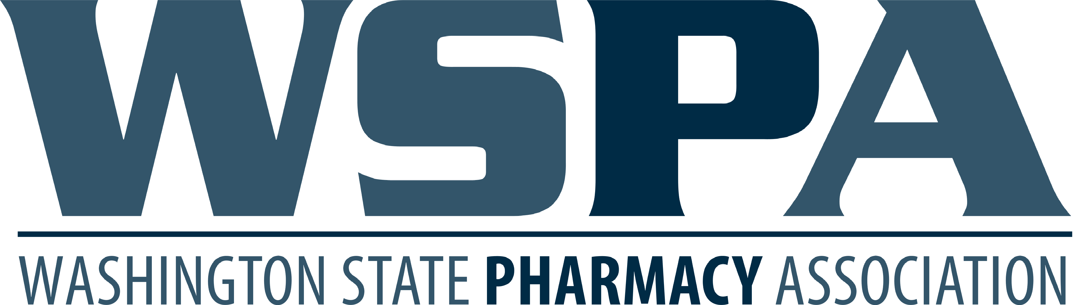

UW Tele-Antimicrobial Stewardship Program Extensions for Community Health Outcomes (UW TASP ECHO 7/1/20-3/30/21)
CE form must be submitted by 4/30/2021 in order to receive credit
CE cannot be uploaded after May 30, 2021

60 minutes webinar via zoom every Tuesday. You must attend a minimum of 15 hours in order to receive credit. Partial credit cannot be issued.

Activity Information:
This activity is designed for Pharmacists and is ACPE accredited for 15 CPE hours, Universal Activity Number 0130-9999-20-192-L01-P | Activity Type: Application | accreditation date: 3/30/2021

At the completion of this activity, the Pharmacist will be able to:
- Recognize and understand the CDC's Core Elements of AS programs
- Apply principles of best practices in AS programs
- Develop and execute an AS program in the hospital setting
- Implement an AS program in the hospital setting

To Earn CE Credit
To receive credit, attendance will be tracked, and at the end of the series complete and hand in a meeting evaluation. Your NABP e-profile ID and birth date (Month\Day) will need to be received by the WSPA in order for you to receive credit. The request for CE must be received by April 30, 2021 for credit to be issued.

The Washington State Pharmacy Association only has 60 days from the accreditation date of the activity to upload the CPE information to the CPE Monitor. It will be your responsibility to check the CPE Monitor before the 60 days to make sure the CE is uploaded in your profile. If there are any problems, you will need to contact WSPA 425-228-7171. CE cannot be uploaded after 60 days from March 30, 2021.

Registration Process
The CE request form must be submitted with payment to receive credit.

The Washington State Pharmacy Association is accredited by the Accreditation Council for Pharmacy Education as a provider of continuing pharmacy education.

CE Request Form: for ACPE Continuing Pharmacy Education

This form must be received by April 30, 2021 in order to receive Credit

This series offers ACPE CPE starting July 1 through May 30, 2021.
Attendance will be taken weekly and submitted to WSPA at the end of March. For pharmacists to get CE credit they must pay the fee below. You can only receive 15 CPE hours. If you have less than 15 hours, you cannot receive credit. ACPE does not allow partial credit. The CE will be uploaded to the CPE monitor as 15 hours, 0130-9999-20-192-L01-P, activity date 3/30/2021, Live event.

This activity is designed for Pharmacists and is ACPE accredited for 15 CPE hours,
Universal Activity Number 0130-9999-20-192-L01-P | Activity Type: Application
Activity Date: 3/30/2021

$75 WSPA Members $95 WSPA Non-Members

$__________ Total Payment 15 CPE (will be uploaded to the CPE Monitor

Name: ______________________________________________________________________________________

Address City| ST | Zip: _________________________________________________________________________

Phone: _______________________________ E-mail: ______________________________________________

*NABP e-Profile ID Number: ________ *Date of Birth (Month-Day): ______

Charge Card: Visa: _____ MasterCard: _____ Discover ______ American Express _____ Check # __________
Cardholder Name: _______________________________ 3 Digit Security Code: _____________________________

Card Number: ___________ - ___________ - ___________ - ___________ Exp. Date: ___________________
Signature: ______________________________________________________________________________
* required in order to receive CPE
You can email the request to maria@wsparx.org, fax to number below or mail to address below: Must be received by 4/30/2021

