UW TASP ECHO  April 1, 2020- March 31, 2021  DS2041 | 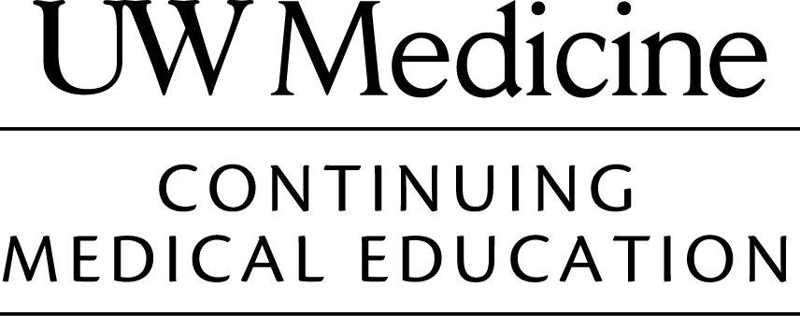

Attendance Verification for AMA Category 1 Credit

University of Washington School of Medicine CME Office and the AMA requires verification for the hours you participate in a CME activity designated for AMA PRA Category 1 Credits™.

To receive your proper number of AMA credit hours:
(CME certificates cannot be issued without submission of a completed form)
- legibly print your name
- indicate # of hours attended and sign on the line
- enter your email address to obtain your certificate via the online portal

The University of Washington School of Medicine designates this live activity for a maximum of 97 AMA PRA Category 1 Credits™.

04/01/2020-03/31/2021 I attended for _____ hours. (92 hours max;1.0 per session

____________, _____________ I attended for _____ hours. (5 hours max: Conference)
Date Location

PRINT
Your Name _____________________________________________
First Last (MD, DO, NP, PA, RN, etc.)
Phone _( )____________Email:__________________________

If you would like to receive a certificate of attendance for credit, please complete this form and return to the CME Office with your check or credit card selection. Please make checks payable to the University of Washington. Once payment is received, your certificate will be available via the CME portal.

Certificate Fees
$25 8.0 hours or less
$35 8.25-16.0 hours
$45 16.25-64.0 hours
$55 64.25-99.75 hours

Mail to: University of Washington
Continuing Medical Education Box 359558
Seattle, WA 98195
Phone: (206) 543-1050
Fax: (206) 221-4525

❑ Enclosing Check (Payable to: University of Washington
❑ Credit Card (if you wish to pay via credit card, please select this box and a link for payment will be sent to the email noted above)
❑ UW Budget: #____________

