

Session Summary for 8 May, 2018

Didactic: A Fungus Among Us. Theodore Wright, MD.

1. What is a fungus?
   1. Multicellular organism with organelles, a cell membrane, and a cell wall. Some are unicellular yeast and others multicellular with hyphae.
   2. Most clinically relevant fungi are within the phylum Ascomycota and reproduce asexually through conidia.
2. Fungal Cell membranes have ergosterol, a fungal version of cholesterol.
3. Fungal cell walls contain Chitin.
4. Amphotericin B binds to ergosterol and prevents its formation of the cell membrane.
5. Azoles Inhibit the synthesis of ergosterol
6. Flucytosine inhibits DNA and RNA synthesis.
7. Echinocandins inhibit beta-D-glucan synthesis thus inhibiting cell wall formation.
8. Intrinsic resistance of fungi

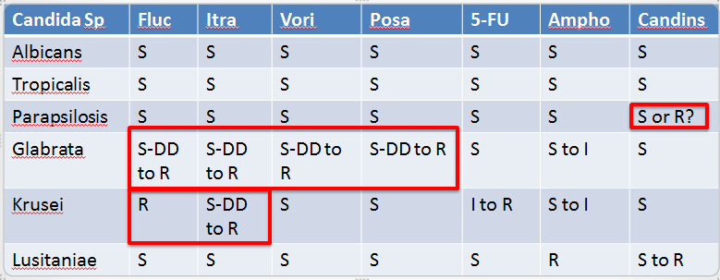

1. Candida is typically a colonizer but in the right situation can cause disease in any organ system and candidemia can have a 47% mortality.
2. Gold Standard for dx is culture.
3. Fungitell (beta-D-glucan testing) often leads to false positives and is of questionable utility.
4. Candida colonization of the lungs.
   1. 22% of healthcare workers and 55% of inpatients will grow candida from the sputum in absence of true candida pneumonia.
   2. True candida pneumonia can occur via candidemia; disseminated hematogenous candida.
   3. Do not treat candida in the sputum in absence of candidemia.
5. Candida UTI:
   1. Asymptomatic candiduria should be treated in the following circumstances:
      1. Neutropenic
      2. Impending urologic procedure
      3. Low birth weight neonates.
   2. Candida cystitis or pyelonephritis is exceedingly rare.
      1. RF include female gender, DM, foley catheter, immunosuppression.
      2. Candida GU infections occur via ascending infection from the GU tract. This mechanism usually presents indolently leading to emphysematous pyelo or renal fungal ball.
      3. Hematogenous GU candida typically presents as renal abscess.
      4. Candiduria should be treated as a UTI or pyelo only if they present with RF, all other etiologies have been ruled out, and they are truly symptomatic.
6. Candidemia – Invasive candida bloodstream infection:
   1. Non-neutropenic
      1. Think CVC as source and remove it.
      2. Start with echinocandin and then step down to fluconazole in 5-7 days.
      3. Always get susceptibilities.
      4. Total duration 14 days from first negative blood cx.
      5. Get optho exam to rule out endopthalmitis.
      6. Check blood cx Qday or QOD until cleared.
   2. Neutropenic
      1. Suspect GI source; translocation.
      2. Treat the same as for non-neutropenic but consider CVC removal on a case by case basis.

Case: Benefit of azithro for SSI prophylaxis in C-section.

1. Ureaplasma and mycoplasma have become appreciated as a cause of SSI and endometritis after C-section. These organisms will not be cultivated on most standard C and S from the OR so their treatment must be done empirically based on RF.
2. Typical SSI prophy for C-section uses cefazolin.
3. A 2016 RCT published in the NEJM (Tita et al) showed that addition of azithromycin to cefazolin pre-op reduced the rates of SSI and endometritis from 12% to 6%.
4. Obesity was a major RF for SSI; specifically a BMI >30.

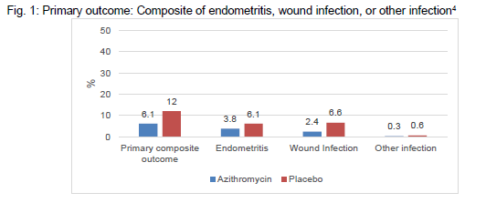

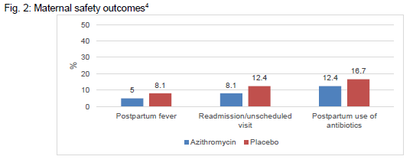

At the University of Washington we have created this protocol for azithro SSI prophy.

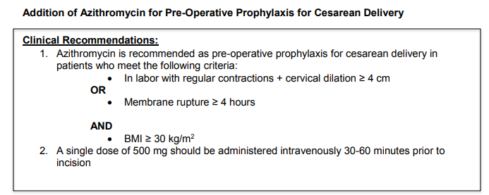

References:

* Meersseman et al. Significance of the Isolation of Candida from airway samples in critically ill patients. Intensive Care Med. 2009. Vol 35.
* Haron et al. Primary Candida Pneumonia. Medicine. 1993. 72(3).
* Meersseman et al. Significance of the Isolation of Candida from airway samples in critically ill patients. Intensive Care Med. 2009. Vol 35.
* <https://en.wikipedia.org/wiki/Taxonomic_rank>
* <https://en.wikipedia.org/wiki/Zygomycota>
* Masur, H; et al. Pulmonary Disease Caused By Candida Species. The American Journal of Medicine. The American Journal of Medicine. 1977.
* Andes; et al. Pulmonary Candidiasis in Patients with Cancer. CID. 2012:54.
* Kontoniyanis; et al. Pulmonary Candidasis in Patients with Cancer. CID. 2002. 34: 400-3.
* Bouza E; et al. A European Perspective on nosocomial UTI. Clinical Microbiol Infect. 2001
* Tita ATN, Szychowski JM, Boggess K, et al. Adjunctive Azithromycin Prophylaxis for Cesarean Delivery. New Engl J Med 2016;375:1231-41.