

Session Summary for 29 May, 2018

Didactic: Odontogenic Infections, Paul Pottinger, MD.

* Odontogenic: Arising from teeth or closely surrounding tissues.
* Major Public Health Failure.
  + 25% of Americans have no teeth by age 60.
* Begins when bacteria adhere to the sugary pellicle layer on the surface of enamel. Grows into plaque and then dental caries. This can then spread to deeper spaces in the neck or even to the heart.
* Oral anaerobes: *Peptostreptococcus, Veillonella, Actinomyces, Lactobacilllus, Prevotella, Fusobacterium, Bacteroides.*
* Oral Aerobes: *Streptococcus, Moraxella, Lactobacillus, Corynebacterium.*
* As dental disease develops the oral flora transition from microaerophilic organisms to anaerobic organisms.

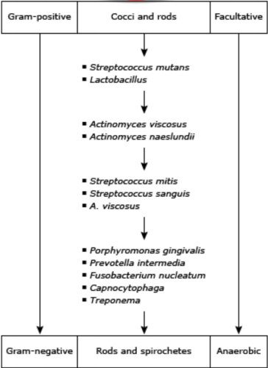

* Periodontal disease: Gum loss threatens tooth viability.
  + Tx with amox/clav 500/125 mg PO BID, or clinda 300mg po TID.
  + Short course (5 days) likely sufficient.
* Mandibular Osteo:
  + Debride it
  + Treat based on micro
* Ludwig’s Angina: Severe cellulitis of the deep space of the floor of the mouth.
  + Tx with amox/clav 500/125 or 875/125 mg PO BID, or clinda 300mg PO TID.
* Odontogenic infections can spread to remote body sites; i.e. osteomytlitis, endocarditis.
* The most essential part of treating odontogenic infections is evaluation by dentist and debridement of the source.
* When possible treat odontogenic infections with amox/clav.
* Clindamycin misses *Eikenella* so is second line.

References:

Albandar JM et al. Destructive periodontal disease in adults 30 years of age and older in the United States, 1988-1994. J Periodontol 1999; 70:13.

Beltrán-Aguilar ED et al. Surveillance for dental caries, dental sealants, tooth retention, edentulism, and enamel fluorosis--United States, 1988-1994 and 1999-2002. MMWR Surveill Summ 2005; 54:1.

Chow AW et al. Ann Intern Med 1978; 88:392.

Chow AW. Odontogenic infections. In: Infections of the Head and Neck, Schlossberg, D (Ed), Springer-Verlag, New York 1987, p.149.