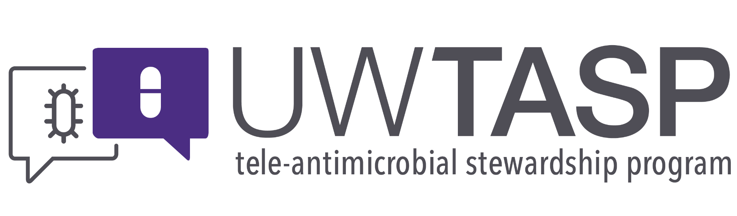

**Session Summary for 1 May 2018**

Didactic: Prolonged Infusion, Is it Worth it?.

1. ~50% of the TASP sites today reported using prolonged Pip/Tazo infusion.
2. At UWMC and HMC prolonged infusion is ordered as a 4.5 gm IV infusion over 30 minutes followed by 3.375 gm IV Q8H beginning 4 hours after the initial loading dose.
3. Means of achieving optimal activity is different for different classes of antibiotics based on their mechanism of action:
   1. Aminoglycosides target peak concentration : MIC
   2. Vancomycin targets AUC : MIC
   3. Beta-lactams target Time above the MIC.
      1. Goal with pip/tazo is 50% of dosing interval above the MIC.
      2. Intermittent dosing of pip/tazo might not always achieve the goal of 50% of the dosing interval above the MIC. 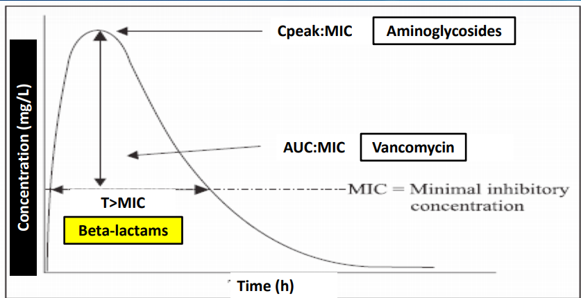
4. Lodise et al. Piperacillin-Tazobactam for Pseudomonas aeruginosa Infection: Clinical Implications of an Extended-Infusion Dosing Strategy. CID. 2007.
   1. 14 day mortality and LOS were both reduced with use of prolonged infusion of pip/tazo.
5. Falagas, ME; et al. Clinical Outcomes with Extended or Continuous Versus Short-term Intravenous Infusion of Carbapenems and Piperacillin/Tazobactam: A Systematic Review and Meta-analysis. CID. 2013.
   1. A meta-analysis also showing reduced mortality amongst those receiving prolonged pip/tazo infusion.
6. Who really benefits from the prolonged infusion of pip/tazo?
   1. Critically ill patients with risk for resistant GNR:
      1. Immunosuppressed.
      2. Significant healthcare exposure; HD, recurrent hospitalizations.
      3. Recent antibiotics.
7. Data shows a mortality benefit to patients with APACHE scores > or = to 17. No difference was noted in LOS or mortality in patients with APACHE , 17.
8. Significance of cost savings:
   1. UWMC/HMC saved $318,901 in 2012 with use of prolonged infnusion of pip/tazop.
   2. Valley medical center cost estimate was for $12,000 savings per year and they have not converted to prolonged infusions of pip/tazo as they have low rates of resistant GNRs.
9. Excellent questions during the session!
   1. What is the risk of nephrotoxicity with intermittent versus prolonged infusions of pip/tazo:
      1. Mousavi, M; et al. Comparisons of Rates of Nephrotoxicity Associated with Vancomycin in combinations with piperacillin-tazobactam administered as extended versus standard infusions. Pharmacotherapy. 2017. 37(3).
         1. Similar rates of nephrotoxicity were seen between patients who received vancomycin in combination with standard or prolonged infusion of pip/tazo.
      2. Cotner, SE; et al. Influence of beta-lactam infusion strategy on AKI. Antimicrobial Agents and Chemotherapy. 2017.
         1. Prolonged versus intermittent infusions of pip/tazo showed no difference in rates of AKI.
   2. Are there issues with transitioning from inpatient prolonged infusion to OPA?
      1. It can be helpful to clearly communicate with the OPAT provider (SNF or clinic) to determine options. If outpatient prolonged infusion is not available then transition to other abx prior to discharging; i.e. intermittent pip/tazo, cefepime, etc.
   3. Why does the extended infusion start 4h after the loading dose?
      1. 4h was selected for convenience and practical purposes.

**References:**

Falagas, ME; et al. Clinical Outcomes with Extended or Continuous Versus Short-term Intravenous Infusion of Carbapenems and Piperacillin/Tazobactam: A Systematic Review and Meta-analysis. CID. 2013.

Lodise et al. Piperacillin-Tazobactam for Pseudomonas aeruginosa Infection: Clinical Implications of an Extended-Infusion Dosing Strategy. CID. 2007.

Mousavi, M; et al. Comparisons of Rates of Nephrotoxicity Associated with Vancomycin in combinations with piperacillin-tazobactam administered as extended versus standard infusions. Pharmacotherapy. 2017. 37(3).

Cotner, SE; et al. Influence of beta-lactam infusion strategy on AKI. Antimicrobial Agents and Chemotherapy. 2017.