

**Session Summary for 6 March 2018**

**Didactic: Antibiotic Time Outs, Paul Pottinger, MD, FIDSA.**

1. Checklists improve safety. Example, aviation.
2. Joint commission now requires that providers evaluate the need of ongoing treatment after a set period of initial treatment; for example, a 48 hour antibiotic time out.
3. Graber, JG; et al. Taking an Antibiotic Time-Out: utilization and Usability of a Self-Stewardship Time-Out Program for Renewal of Vancomycin and Piperacillin-Tazobactam. Hosp Pharm. 2015:50(11).
   1. Antibiotic time outs reduced inappropriate continuation of vancomycin.
4. Antibiotic Time Outs are a form of checklist.
   1. Right diagnosis?
   2. Right drug?
   3. Right dose? Route? Interval?
   4. Right Duration?
5. Antibiotic Time Outs come in different forms.
   1. Automatic 48 hour alert in the EHR.
   2. Prompts providers to re-assess need for abx.
   3. Team documents if antibiotics should continue, change, or stop.

**Case: Delayed outpatient antibiotic prescribing.**

Tyler, in Wenatchee, provided an excellent case of a patient with URI symptoms who was prescribed antibiotics on their second visit to clinic with URI symptoms. This was frustrating to the patient because they felt they should have been provided abx on the first visit. How do we reduce inappropriate outpatient antibiotic prescribing and satisfy our patients?

There are some excellent resources from the CDC and the Washington DOH to help in this. These include a poster from the Washington DOH stating your clinic’s unified commitment to appropriate antibiotics prescribing. The CDC provides “prescription pads” for symptomatic management of viral URI to help you make the patient feel like you addressed their needs and heard them as well as sent them home with an actual diagnosis and guidelines for management.

1. <https://www.cdc.gov/antibiotic-use/community/index.html>
2. <https://www.cdc.gov/antibiotic-use/community/improving-prescribing/evidence/dataforactionaction.html>



CDC resources on outpatient delayed antibiotics and symptomatic therapy for viral infections can be found at: <https://www.cdc.gov/antibiotic-use/community/materials-references/print-materials/hcp/index.html>

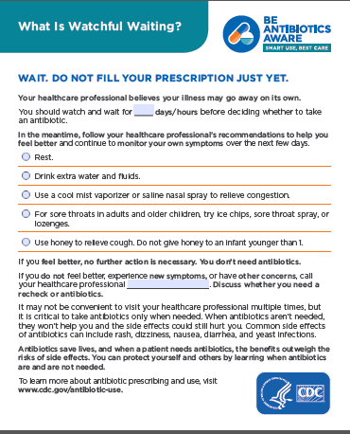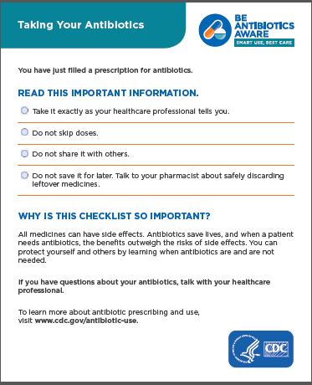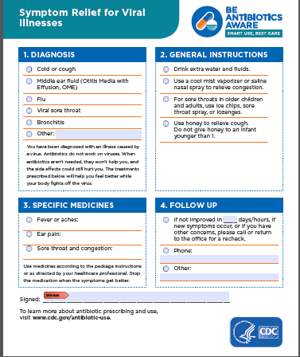

The Washington State DOH has a poster that can be placed in your clinic stating your commitment to avoiding unnecessary antibiotics in the outpatient setting:



1. Excellent Cochrane Review on Delayed Antibiotic Prescriptions for Respiratory Infections.
   1. Spurling, GKP; Del Mar, CB; Dooley, L; Foxlee, R; Farley R. Delayed Antibiotic Prescriptions for Respiratory Infections. Cochrane Database of Systematic Reviews. 2017. Issue 9.

