

Session Summary for 27 March 2018

Didactic: Toolkit SSTI.

1. Flavors of SSTI:
   1. Impetigo: Superficial epidermis, typically GAS. Can treat with topical bacitracin/polymyxin b/neomycin.
   2. Folliculitis: Infection of dermis surrounding hair follicle and shaft.
   3. Erisypelas: Infection of the lymphatics just below the dermis and of the dermis.
   4. Cellulitis: Infection of dermis and subcutaneous fat.
2. Misdiagnosis and overtreatment is a real problem!
   1. >700,000 hospitalizations per year.
   2. 65% increase since 1999 with 4 million ER visits in 2010.
   3. Overtreatment leads to resistance, SJS, hyperkalemia, renal failure, neuropathy, and c diff.
3. Kamath, RS; et al. Guidelines vs actual management of skin and soft tissue infections in the ED. OFID.
   1. Excellent article laying out the misuse of abx in the ED.
      1. We use the inappropriate abx in 21-80% of patients depending on type of SSTI. Often over-treating people with mild SSTI and under-treating people with severe SSTI.
4. Walsh, TL; et al. Appropriateness of antibiotic management of uncomplicated SSTI in hospitalized adult patients. Open access.
   1. Only 20% of patients received appropriate duration of abx.
   2. 51% receive 10-14 days of abx. Over twice the recommended duration!
   3. 28% received >14 days of abx. Almost three times the recommended duration!
5. Mcreary et al. Top 10 myths regarding the diagnosis and treatment of cellulitis. Journal of Emergency medicine. 53(4). 2017.
   1. Great article highlighting myths of SSTI.
6. Gibbons, JA; et al. Antimicrobial Stewardship of SSTI.
   1. Excellent article demonstrating effectiveness of stewardship on prescribing habits for SSTI.
7. IDSA guideline algorithm for SSTI treatment reviewed.
8. Alternative algorithm from JAMA discussed.
   1. Raff, AB; et al. Cellulitis: A Review. JAMA. 2016. 316(3).
9. Talan, DA; et al. TMP/SMX versus placebo for uncomplicated skin abscesses. NEJM. 2016. 374:9.

Daum. RS; et al. A Placebo-Controlled Trial of Antibiotics for Smaller Skin Abscesses. NEJM. 2017. 376:26.

Two NEJM articles discussed. These provided evidence for treating uncomplicated MRSA abscesses that have been drained. However, they used doses and durations of TMP/SMX far beyond the IDSA guideline recommendation. IDSA guidelines still suggest it is not necessary to prescribe abx after adequate I and D of an uncomplicated abscess.

Case Discussion/Questions

Q. Is the dose of azithromycin in CAP supposed to be 500mg on day 1 then 250mg daily x 4 or 500mg daily x 5 days? I have seen it referenced both ways.

***A. Both dosing regimens have been studied and are appropriate. 2007 IDSA guidelines for Community Acquired Pneumonia do not specify an azithromycin dose.***

**Arguments in favor of Lower Dose: 500x1 then 250mg daily:**

* Lends itself well to outpatient use because of the pre-packaged dosing of azithromycin.
* Azithromycin received FDA-approval for CAP under these dosing guidelines, though the package insert specifies mild-severity1
* This dose is sufficient for treatment of atypical pneumonia2

**Arguments in favor Higher Dose: 500mg daily**

* If using azithromycin monotherapy for CAP, I would favor the higher dose, 500 mg
* In hospitalized patients with more severe illness, the 500mg dose + ceftriaxone was comparable to levofloxacin 500 mg daily3
* For standard dosing in the hospital, 500mg q day may be more practical and allows for shorter courses (3 days)2 particularly if used in combination with a beta-lactam.

**References**:

1. Package Insert. [Azithromycin] Revised 3/2017. <http://labeling.pfizer.com/ShowLabeling.aspx?id=511>
2. Schönwald S, Skerk V, Petricevic I, et al. Comparison of three-day and five-day courses of azithromycin in the treatment of atypical pneumonia. Eur J Clin Microbiol Infect Dis. 1991 Oct;10(10):877-80.
3. Zervos M, Mandell LA, Vrooman PS et al. Comparative efficacies and tolerabilities of intravenous azithromycin plus ceftriaxone and intravenous levofloxacin with step-down oral therapy for hospitalized patients with moderate to severe community-acquired pneumonia. Treat Respir Med. 2004;3(5):329-36.

Q: *C. difficile* testing in patients with inflammatory bowel disease (Crohn’s or ulcerative colitis)

***A: In pts with known IBD, very difficult to determine if symptoms due to CDI or a flare, so reasonable to check for C diff. If concerned about a new diagnosis of IBD, C diff status shouldn’t delay diagnostic process, including endoscopy.***

We were able to find one set of recommendations for an approach for this patient group and CDI testing and treatment.

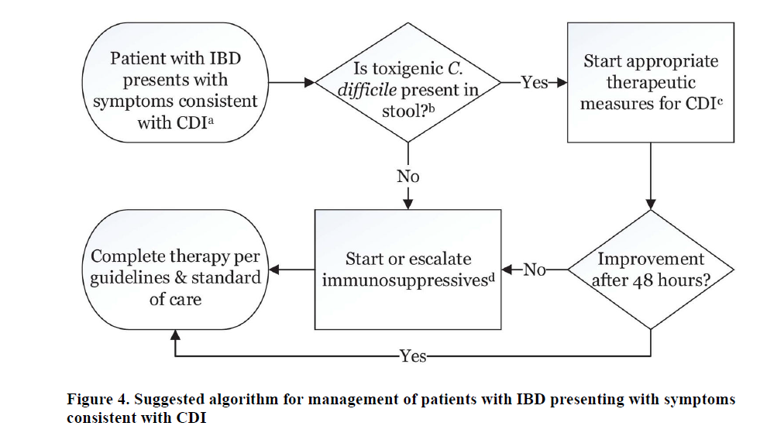

Rao, K. & Higgins, P. D. R. Epidemiology, Diagnosis, and Management of Clostridium difficile Infection in Patients with Inflammatory Bowel Disease. *Inflamm. Bowel Dis.* **22,** 1744–1754 (2016).