

**Session Summary**

March 19, 2019

**Didactic:** Treatment for Gram-Negative Bacteremias

**Speaker:** Zahra Kassamali-Escobar, PharmD

**Key Points:**

Common pathogens: *E. coli, Klebsiella* species, *Proteus* species, +/- *Pseudomonas* species

* Duration of therapy? With source control and clinical improvement = 7 days

Yahav, D. *et al.* Seven versus fourteen Days of Antibiotic Therapy for uncomplicated Gram-negative Bacteremia: a Non-inferiority Randomized Controlled Trial. *Clin. Infect. Dis.* (2018). doi:10.1093/cid/ciy1054

Important point to consider- does this study population represent your hospital’s population? Study conducted in Italy and Israel, 68% urinary source, almost all Enterobacteriaceae. About 50% of patients in both arms had complications, notably readmissions.

* Converting from IV to PO?

Kutob, L. F. *et al.* Effectiveness of oral antibiotics for definitive therapy of Gram-negative bloodstream infections. *Int. J. Antimicrob. Agents* **48**, 498–503 (2016).

Retrospective study of effectiveness of PO antibiotics for GN-BSI. PO antibiotics stratified into 3 categories: high (levofloxacin), moderate (ciprofloxacin and TMP/SMX) and low PO bio-availability (beta-lactams). Mean age 63 years, source 70% urinary.

Outcomes by category:

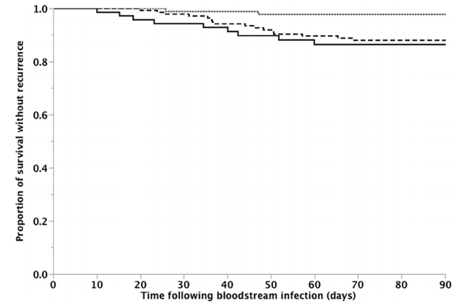

Top line represents high PO bio-available antibiotics, the dashed line represents the moderate PO bio-available antibiotics, and the solid lower line represents the low PO bio-available antibiotics.

Discussion by the group included:

* + Appropriate dosing for TMP/SMX - for serious infections most recommend 2 DS tabs PO BID
  + Concerns about safety of fluoroquinolones - for serious infections, risk-benefit needs to be assessed and goal should be to minimize overall fluoroquinolone exposure
* When is Day 1 of treatment?
  + When empiric therapy is started or
  + When directed therapy is started or
  + When blood cultures clear

Group answer: when antimicrobial therapy that covers the infection is started = Day 1

Canzoneri, C. N., Akhavan, B. J., Tosur, Z., Andrade, P. E. A. & Aisenberg, G. M. Follow-up Blood Cultures in Gram-Negative Bacteremia: Are They Needed? *Clin. Infect. Dis.* **65**, 1776–1779 (2017).

Retrospective study of 500 cases of bacteremia, additional (follow-up) blood cultures had no impact on treatment outcomes in the setting of GN-BSI.   
Important note: This is different than the approach for Gram-positive bacteremia, especially *S. aureus* bacteremia, which requires repeat blood cultures to determine negative cultures and Day 1 status.

**Case Discussions:**

Confluence Health presented 2 tools.

1. Outpatient antimicrobial recs by syndrome/diagnosis
   * Comprehensive document to give prescribers specific recommendations on treatment, either symptomatic or antimicrobial, including duration
   * Included hydration rec for UTI prevention!
   * Confluence is also removing a default duration of “10-days” for outpatient order sets.
   * Discussed monitoring AU by syndrome as a metric for tracking effectiveness of tool
   * Discussion on keeping doc updated
2. Non-antibiotic “prescription” document for outpatient use
   * Available as printed doc and EPIC dot phrase
   * Discussed how implementation in specific clinics and community outreach (social media, Doc Talks, etc.)

The group also discussed challenge with patient perception of what “upper respiratory tract infection” means. “Infection” often means “antibiotics are needed” to patients. Recs included using “viral syndrome” (from Forks team), “chest cold” and “head cold”. Nicole Poole from SCH mentioned using “nasty virus” to acknowledge that viral infections can be serious. (See references for a paper from 2000, “The Language of Infectious Disease: A Light-Hearted Review” by Lettau for a related, though tangential, read). The need for a specific outpatient pediatric approach was discussed as the treatments differ from adults and the empathetic approach is key.

Forks presented their experience with becoming the first critical access hospital in the United States to become certified in “Managing Infection Risk”. This certification is like the process for hospital accreditation and required leadership and participation by the entire hospital. Congratulations to the whole Forks team and community on achieving this!

More info: https://www.dnvglhealthcare.com/certifications/managing-infection-risk

**Thanks! The UW TASP Team**

**References:**

Yahav, D. *et al.* Seven versus fourteen Days of Antibiotic Therapy for uncomplicated Gram-negative Bacteremia: a Non-inferiority Randomized Controlled Trial. *Clin. Infect. Dis.* (2018). doi:10.1093/cid/ciy1054

Kutob, L. F. *et al.* Effectiveness of oral antibiotics for definitive therapy of Gram-negative bloodstream infections. *Int. J. Antimicrob. Agents* **48**, 498–503 (2016).

Canzoneri, C. N., Akhavan, B. J., Tosur, Z., Andrade, P. E. A. & Aisenberg, G. M. Follow-up Blood Cultures in Gram-Negative Bacteremia: Are They Needed? *Clin. Infect. Dis.* **65**, 1776–1779 (2017).

Lettau, L. A. The language of infectious disease: a light-hearted review. *Clin. Infect. Dis.* **31**, 734–738 (2000).