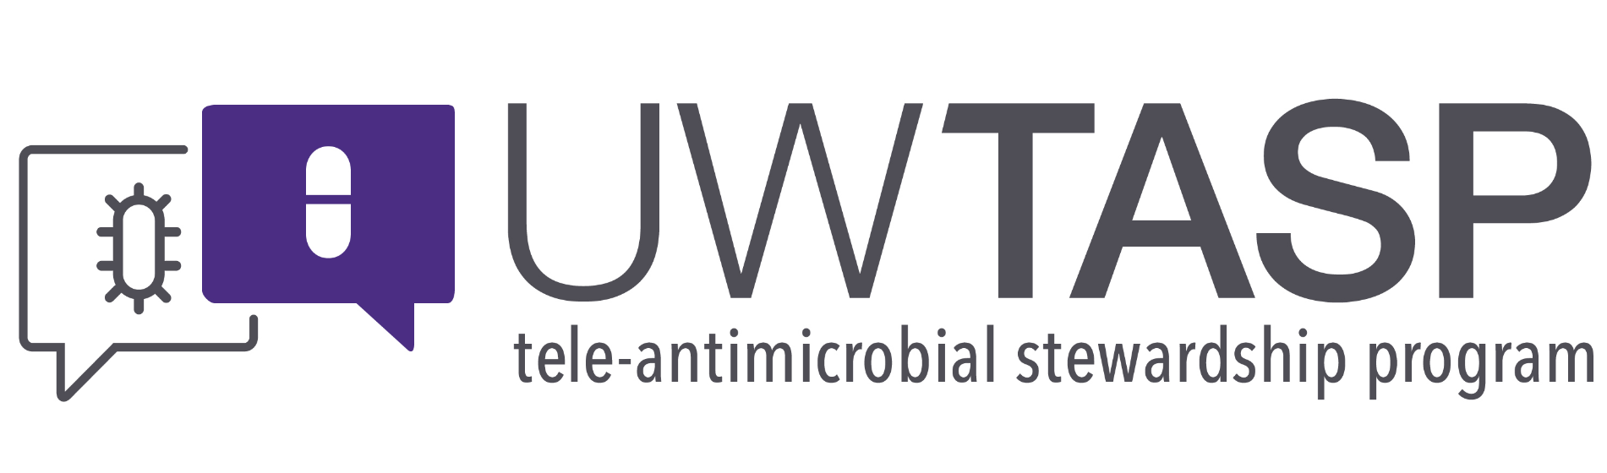

**Session Summary for October 9th, 2018**

Didactic: Big Bad GNRs Part 2- Treatment: Paul Pottinger, MD.

Slides available on UWtasp.org

Testing of Carbapenem Resistant Enterobacteriaceae

* WA State Lab is able to do expedited resistance testing for carbapenem resistant gram negative organisms, free of charge to the organization
* Coordinate with Kelly Kauber at 206-418-5589 *or* [*kelly.kauber@DOH.wa.gov*](mailto:kelly.kauber@DOH.wa.gov)

Case Discussion: Group A Strep pharyngitis on the rise

* Streptococcus pyogenes (aka Group A Strep, GAS) is known to both colonize the pharynx and to cause true bacteria pharyngitis
* GAS pharyngeal carriage ranges from 6-20%. Rapid GAS antigen testing and culture are unable to differentiate between carriage and true infection
* Thus, guidelines and current data strongly urge the use of clinical decision rules (Centor Criteria)1 to help guide testing (i.e. if the pre-test probability for GAS pharyngitis is low, testing should not be performed)
* The CDC does not recommend treating contacts of GAS pharyngitis infection, rather recommends close monitoring for symptoms for 30 days with good counseling.
* Negative rapid antigen testing in children should be followed-up by culture for regulatory purposes. This is not needed required for adults.
* Helpful, evidence based communication strategies for providers are available below on the DART leaning modules.

References:

1. Centor Criteria: <https://www.mdcalc.com/centor-score-modified-mcisaac-strep-pharyngitis>.

WA DOH guidelines: https://www.doh.wa.gov/Portals/1/Documents/2700/GroupA.pdf

Centor Criteria: <https://www.mdcalc.com/centor-score-modified-mcisaac-strep-pharyngitis>

AAFP recs: https://www.aafp.org/afp/2016/0701/p24.html CDC GAS Disease page: <https://www.cdc.gov/groupastrep/diseases-hcp/strep-throat.html>

DART Learning Modules: <https://www.seattlechildrens.org/research/centers-programs/child-health-behavior-and-development/labs/mangione-smith-lab/dart-learning-modules>

Thank you everyone for another great TASP session. See you next week!

Chloe Bryson-Cahn, MD

On behalf of the UW TASP ECHO Specialist Team:

*John Lynch, MD MPH*

*Chloe Bryson-Cahn, MD*

*Jeannie Chan, PharmD*

*Zahra Kassamali Escobar, PharmD*

*Hannah Imlay, MD*

*Rupali Jain, PharmD*

*Paul Pottinger, MD FIDSA*

PLEASE NOTE that Project ECHO case consultations do not create or otherwise establish a provider-patient relationship between any UW Medicine Health Care Professional and any patient whose case is being presented in a Project ECHO setting.  A provider-patient relationship between a UW Medicine Health Care Professional and a patient whose case was presented at Project ECHO may later be established if the patient is referred and seen in the context of a regular appointment with the UW Medicine Health Care Professional.