UW TASP_LogoExploration_RGB_Color.jpg

**Session Summary for 06 February 2018**

**Didactic:** Antibiotic Stewardship for Respiratory Tract Infections

Speaker: Zahra Kassamali Escobar

Key points:

* Many abx durations are arbitrary...remember the "Constantine Unit" [(Spellberg 2018)](https://paperpile.com/c/S6lZ7E/tlyP)
* Symptom-guided duration for CAP = safely d/c abx on day 5 if meeting specific markers of improvement [(Uranga et al. 2016)](https://paperpile.com/c/S6lZ7E/O4gj)
* The Valley Medical Center “sticky note”

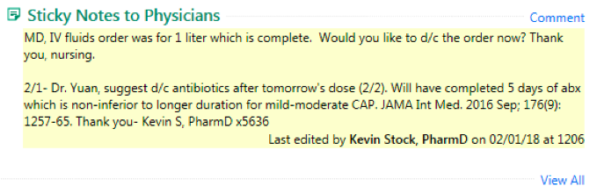

* The 3-step pathway paper[(Carratalà et al. 2012)](https://paperpile.com/c/S6lZ7E/kMgk)
  + Early mobilization
  + IV to PO conversion
  + Predefined criteria for discharge
  + BUT, implementation…..
* MRSA surveillance swabs are very good negative predictors of MRSA respiratory tract infection (negative swab = MRSA very very unlikely). Nice opportunity for stewardship. [(Chotiprasitsakul et al. 2018; Chan et al. 2012)](https://paperpile.com/c/S6lZ7E/B9GS+NXYX)

**Cases**

1. Shannon @ Jefferson

Possible COPD exacerbation 2nd to RSV, treated for CAP, intubated. *S. viridans* from sputum likely local non-pathogenic bacteria. When improved and extubated, MDR Pseudomonas isolated and treated with high dose cefepime + gentamicin. Patient improved then worsened, then treated again, improved.

Key take-aways:

* RSV can put adults in the ICU
* Unclear if CAP or COPD exacerbation
* Value of sputum culture dependent on diagnosis, quality of specimen and timing. Usually not helpful if patient improving
* Given high MIC, cefepime likely not indicated, but very difficult to treat organism if truly infected. Based on the sensis alone, rec ID consult (transfer PRN)
* Incredibly complicated patient who survived due to some outstanding care

1. Colleen @ Whidbey

Likely GI bleed headed for colonoscopy tested for *C. difficile* to determine safety of scoping (?). Treated with PO metronidazole and PO vancomycin and scope delayed due to + test.

* *C. difficile* is a common colonizer (5% to 50% depending on population sampled)
* *C. difficile* infection does not cause hemorrhagic diarrhea
* *C. difficile* disease is “usually” defined as 3 or more very loose, diarrheal bowel movements within 24 hours, off laxatives and often accompanied by leukocytosis, abdominal pain and/or fever.
* For mild to moderate CDI, metronidazole 500mg PO TID x 10-14 days is recommended (not q6) or vancomycin 125mg PO q6 hrs x 10-14 days. Higher doses are not recommended due to toxicity (metronidazole) and lack of benefit (both metronidazole and vancomycin)
* Labs will generally not reject a stool specimen if it takes the shape of the cup (rough criteria) and will not assess other characteristics (in this case mucous and blood).

Next week’s didactic: Spine Infections

Thanks for another great sesssion!  
  
- John and the rest of the UW TASP team

**References**

Chotiprasitsakul, D., Tamma, P. D., Gadala, A. & Cosgrove, S. E. The Role of Negative Methicillin-Resistant Staphylococcus aureus Nasal Surveillance Swabs in Predicting the Need for Empiric Vancomycin Therapy in Intensive Care Unit Patients. *Infect. Control Hosp. Epidemiol.* 1–7 (2018).

Carratalà, J. *et al.* Effect of a 3-step critical pathway to reduce duration of intravenous antibiotic therapy and length of stay in community-acquired pneumonia: a randomized controlled trial. *Arch. Intern. Med.* 172, 922–928 (2012).

Uranga, A. *et al.* Duration of Antibiotic Treatment in Community-Acquired Pneumonia: A Multicenter Randomized Clinical Trial. *JAMA Intern. Med.* 176, 1257–1265 (2016).

Spellberg, B. The Maturing Antibiotic Mantra: ‘Shorter Is Still Better’. *J. Hosp. Med.* (2018). doi:10.12788/jhm.2904