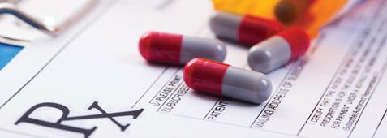

Disposing safely of unwanted medication

Properly disposing of medications can improve the safety of our environment and communities by reducing the risk of accidental exposure, intentional misuse, and contamination of our environment.

According to the Federal Drug Enforcement Agency, on the last Take Back Day in October 2018, Washington State collected 15,604 pounds of unwanted medications. Since 2011, over 224,037 pounds of unwanted medicines have been returned and safely destroyed in Washington.

Drug take-back programs accept most medications, including:

* Prescription drugs and over-the-counter medications
* Vitamins
* Pet medications
* Medicated ointments and lotions

Follow any specific disposal directions that apply to the medications you take. Certain medications, such as fentanyl patches, have specific disposal directions. Ask your pharmacist about any special disposal directions for your medications.

Where do I dispose of my unused medications?

Take Back Your Meds Program: Take back locations are located across Washington. Go to: <http://www.takebackyourmeds.org/>

Dispose My Meds Program: To find a participating independent pharmacy to drop off medications, go to: <http://disposemymeds.org/medicine-disposal-locator/>. Before going, contact the pharmacy to confirm they provide this service.