

**Hospital: Bonner General (Sandpoint, ID)**

**Presenter: Kathy Trosin**

**Question/case summary:**

Pregnant woman with recurrent trichomoniasis. S/p treatment with single dose of metronidazole, did well for a short time then recurred. Sexual partner was also treated (asymptomatic). Is there a problem with drug resistance in *T. vaginalis*?

**UW TASP Recommendations:**

*Trichomonas vaginalis* is a protozoan sexually transmitted infection (STI) and the most common non-viral STI in the United States (~3.7 million infections per year). It is transmitted during sexual intercourse from penis to vagina, vagina to penis and vagina to vagina. Only 30% of infections are symptomatic and more commonly symptomatic in women. Time from exposure to symptoms ranges from 5-28 days. Symptoms in women include pruritis, dysuria, soreness, and a change in vaginal discharge. Men typically experience urethritis, pruritis and penile discharge.

Trichomoniasis is particularly problematic in pregnancy. Infection is associated with preterm delivery and underweight infants. Infection is also a risk factor for other STIs.

A common point of care (POC) test for trichomoniasis is a wet mount and visualization of motile organisms, but sensitivity of this test ranges from 36% to 70%. The gold standard is now the nucleic acid amplification tests (NAATs) (no longer culture as was described during TASP). At Harborview, the lab does both wet mounts and NAATs. If a wet mount is negative, it reflexes to NAAT. NAATs are less useful for monitoring of recurrent or persistent infection as non-viable organisms may be detected by NAAT.

Per the 2015 CDC STD Treatment Guidelines, the preferred treatments are:

* Metronidazole (MTR) 2 grams PO x 1
* Tinidazole (TIN) 2 grams PO x 1
* Alt: metronidazole 500 mg PO BID x 7 days

Sexual partners must be treated as well to prevent re-infection. Both individuals should abstain from intercourse x 7 days after starting therapy.

Some experts recommend the 7 day regimen due to increasing failure rates with single dose regimens, especially metronidazole. Detection of varying levels of metronidazole resistance are increasing, but require culture and testing at the CDC lab. The level of resistance to tinidazole is much lower, but the drug tends to be more expensive than metronidazole.

Strategies for treatment when single dose MTZ fails and re-infection is excluded:

* MTZ 500 mg PO BID x 7 days

If this doesn’t work:

* MTZ or TIN 2 grams PO daily x 5-7 days
* Check susceptibilities

Alternatives:

* Intravaginal boric acid 600 mg gelatin capsules BID x 14 days

NOT Recommended: betadine douches, clotrimazole, acetic acid topical microbicides, furazolidone, gentian violet, potassium permanganate, nonoxynol-9

Resistance data from Emerg Infec Diseases 2012:

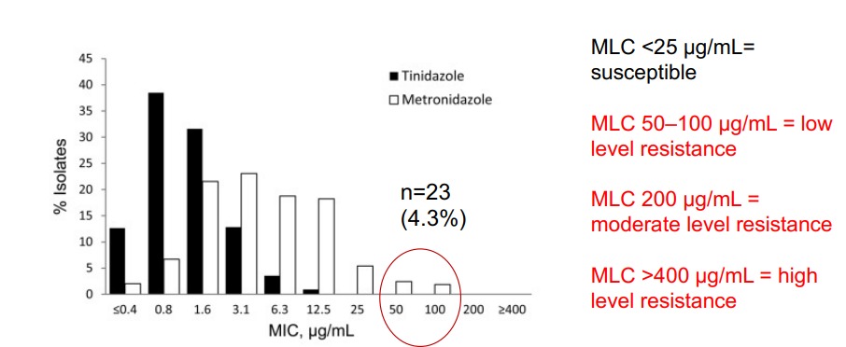

On behalf of the UW TASP Specialist Team:

*John Lynch, MD MPH*

*Chloe Bryson-Cahn, MD*

*Jeannie Chan, PharmD*

*Zahra Kassamali Escobar, PharmD*

*Rupali Jain, PharmD*

*Paul Pottinger, MD FIDSA*

PLEASE NOTE that UW TASP case consultations do not create or otherwise establish a provider-patient relationship between any UW Medicine Health Care Professional and any patient whose case is being presented in a UW TASP setting.  A provider-patient relationship between a UW Medicine Health Care Professional and a patient whose case was presented at UW TASP may later be established if the patient is referred and seen in the context of a regular appointment with the UW Medicine Health Care Professional.