

**Hospital: Lincoln**

**Presenter: Merilla Hopkins**

Question/case summary:

 Last year I put together a dosing reference for our providers using the exact same doses as you guys – see below.

However, this year as I have been perusing different protocols just from the web, I came across some facilities recommending

CrCl > 30 ml/min – 75 po bid

CrCl< 30 ml/min – 75 mg po daily

I hadn’t started searching for any literature to support this dosing, however I was intrigued with the option since it would streamline inventory and be less confusing to providers.  I’ll do some more in depth looking at these “published” protocols to see if they have references to support this or try to figure out where it came from.

One other question – my recommendation on this chart had been to continue treatment > 5 days for inpatients with severe disease if they were still sick…  What is your policy on that population?

Thanks for the info.

|  |  |  |  |
| --- | --- | --- | --- |
| **Oseltamivir (Tamiflu) Dosing** | | | |
| **Pediatrics LESS THAN 1 year old** | | | |
| **Dose by age/weight** | **Treatment (see below)** | | **Prophylaxis-within 48 hrs of exposure** |
| **Infants < 3 mos**  **(per CDC)** | 3 mg/kg PO bid x 5 days | | Prophylaxis not recommended for infants < 3 months unless clinically critical (per CDC) |
| **Peds**  **3-12 months** | 3 mg/kg/dose bid x 5 days (CDC) | | 3 mg/kg daily x 10 days |
| **Pediatrics > 1 year old** | | | |
| **≤ 15 kg** | | 30 mg PO bid x 5 days | 30 mg PO daily x 10 days |
| **15 kg – 23 kg** | | 45 mg PO bid x 5 days | 45 mg PO daily x 10 days |
| **23 kg – 40 kg** | | 60 mg PO bid x 5 days | 60 mg PO daily x 10 days |
| **≥ 40 kg** | | 75 mg PO bid x 5 days (adult dosing) | 75 mg PO daily x 10 days (adult dosing) |
| **ADULTS** | | | |
| **Dose by Renal Function** | | **Treatment –**within 48hrs of sxs onset for outpatients.  Initiate ASAP in hospitalized pts regardless of time of presentation of sxs onset.  Consider longer duration in severely ill pts who remain severely ill after 5 days of therapy (CDC) | **Prophylaxis-within 48 hrs of exposure** |
| **Adults**  **CrCl > 60 ml/min** | | 75 mg PO bid x 5 days | 75 mg PO daily x 10 days |
| **Adults**  **CrCl 30-60 ml/min** | | 30 mg PO bid x 5 days | 30 mg PO daily |
| **Adults**  **CrCl 10-30 mls/min** | | 30 mg PO daily x 5 days | 30 mg PO every other day x 5 doses |
|  |  |  |  |

UW TASP Recommendations:

Among adults, the data show that higher oseltamivir doses are well-tolerated but not more efficacious.

If it is advantageous to streamline formulary (or minimize confusion among providers) it is reasonable to use the 75 mg dose for all patients. The 2008 and 2012 oseltamivir package inserts are still available online for your reference in making the dose adjustments

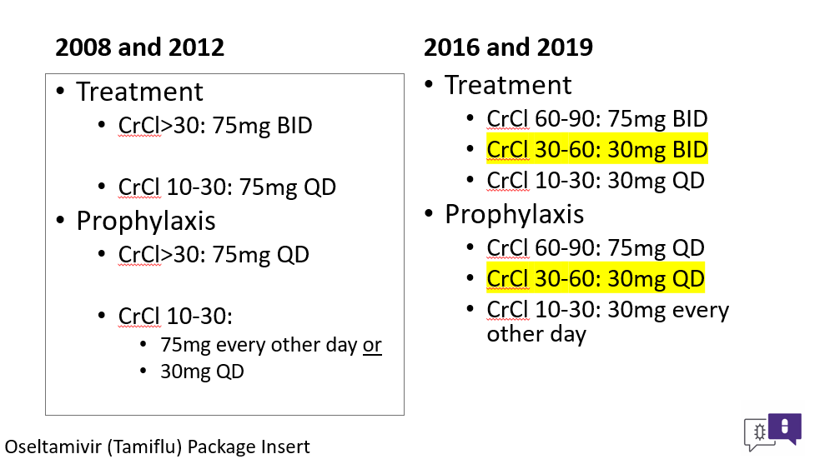

Regarding increasing duration of therapy > 5 days among inpatients with severe influenza illness:   
  
In patients who are immunocompromised or who are critically ill, they may have prolonged viral replication and could potentially benefit from duration > 5 days.

Among critically ill patients with high ventilation needs and ongoing positive influenza PCR/culture, our practice has been to continue oseltamivir for longer durations. The specific duration is patient-specific based on signs and symptoms.

On behalf of the UW TASP Specialist Team:

*John Lynch, MD MPH*

*Chloe Bryson-Cahn, MD*

*Jeannie Chan, PharmD*

*Zahra Kassamali Escobar, PharmD*

*Rupali Jain, PharmD*

*Paul Pottinger, MD FIDSA*

PLEASE NOTE that UW TASP case consultations do not create or otherwise establish a provider-patient relationship between any UW Medicine Health Care Professional and any patient whose case is being presented in a UW TASP setting.  A provider-patient relationship between a UW Medicine Health Care Professional and a patient whose case was presented at UW TASP may later be established if the patient is referred and seen in the context of a regular appointment with the UW Medicine Health Care Professional.