Valor Asymptomatic Bacteriuria (ASB) Report
Date of Report: July 2024*
*This data report is based on cases submitted from September 2023 – June 2024 and does not include previous data.
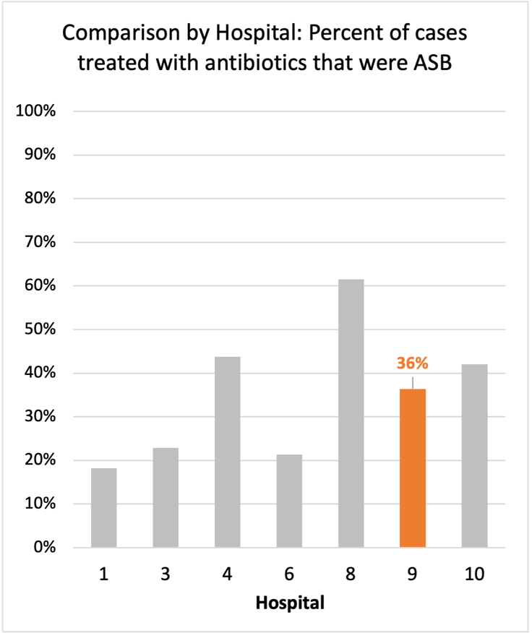
Inappropriate Diagnosis of UTI measure
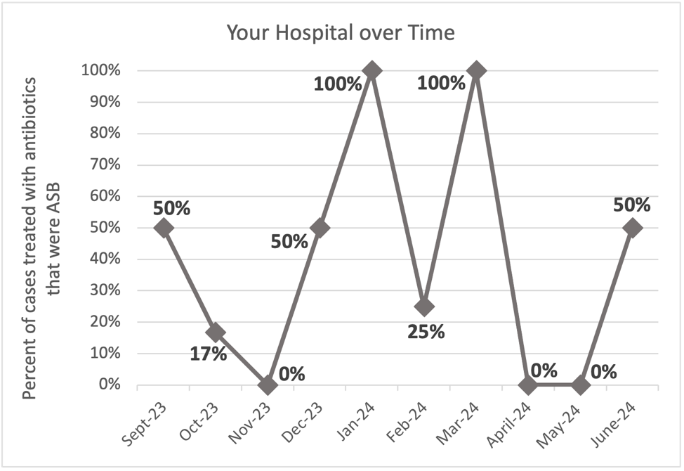
Average across hospitals in cohort: 35.6% ; HMS Hospital Average*: 23.2%
Inappropriate Diagnosis of UTI measure: $\frac{Number of patients treated for ASB}{Number of positive urine cultures treated (UTI+ASB)}$
- Goal: lower % = better
- You can lower this number by either reducing unnecessary urine cultures (diagnostic stewardship) or reducing antibiotic treatment when unnecessary cultures are obtained (antibiotic stewardship)
*The HMS hospital average was amongst 46 hospitals in the Michigan Hospital Medicine Safety Consortium that participated in a similar quality improvement study.

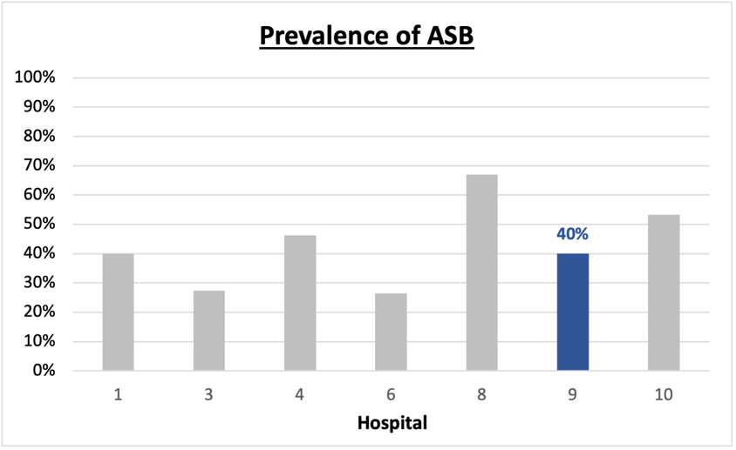
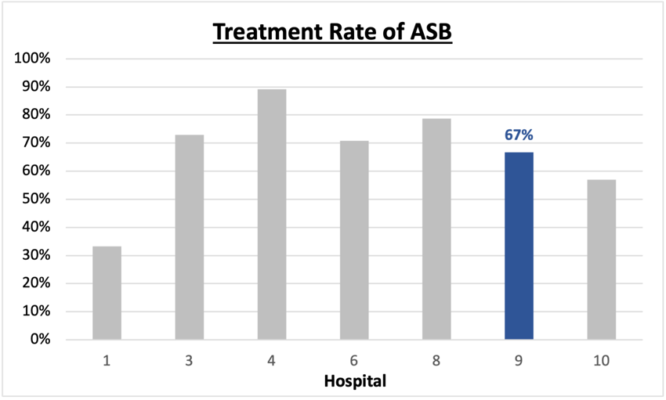
Prevalence and Treatment Rate of ASB

$$\frac{Number of ASB cases}{Number of positive urine cultures}$$
Prevalence of ASB:
$$\frac{Number of treated ASB cases}{Number of ASB cases}$$
Treatment Rate
of ASB:

Data submissions
Total cases (positive urine cultures) included for your site: 45
Cases included per month for your site (median & IQR): 4.5 (3.25-5.75)

Prevalence of ASB
Prevalence of ASB across hospitals: 356 of 868 (41.0%)
Prevalence of ASB at your site: 18 of 45 (40%)

Treatment Rate of ASB
Treatment rate of ASB in overall cohort: 266 of 356 (74.7%)
Treatment rate of ASB at your site: 12 of 18 (66.7%)
Previous treatment rate at your site (from ASB 101 cohort): 16 of 16 (100%)

Antibiotic Tables
Table 1: Three Most Common Antibiotics comparing UTI & ASB
IV |  | Oral
UTI, n = 6 | ASB, n = 6 | UTI, n = 20 | ASB, n =13
Ceftriaxone (n=5) | Ceftriaxone (n=6) | Cephalexin (n=6) | Cephalexin (n=4)
Levofloxacin (n=1) |  | Nitrofurantoin (n=6) | Ciprofloxacin (n=2)
 |  | Trim-sulfa (n=2) | Nitrofurantoin (n=2)
Table 2: Antibiotic Duration (days) | UTI |  | ASB
 | Prior, n=25 | This Month, n=2 | Prior, n=15 | This Month, n=3
Total Antibiotic Duration; median (IQR) | 7 (3-8) | 5 (2.5-7.5) | 6 (0.5-7) | 0 (0-3.5)
Number of Cases Receiving >7 days; n (%) | 7 (28%) | 1 (50%) | 2 (13.3%) | 0

Prior is Sept 2023 - May 2024 & this month is June 2024
Table 3: Characteristics comparing this month to prior n (%) | UTI |  | ASB
 | Prior, n=25 | This Month, n=2 | Prior, n=15 | This Month, n=3
Setting where culture obtained
ED, then admitted | 1 (4%) | 0 | 3 (20%) | 1 (33.3%)
ED, then discharged | 11 (44%) | 2 (100%) | 12 (80%) | 2 (66.7%)
Ambulatory care clinic | 7 (28%) | 0 | 0 | 0
Inpatient | 0 | 0 | 0 | 0
Other | 6 (24%) | 0 | 0 | 0
From reflex test | 15 (60%) | 2 (100%) | 13 (86.7%) | 1 (33.3%)
Men | 4 (16%) | 1 (50%) | 6 (40%) | 0
Age >75 | 9 (36%) | 1 (50%) | 8 (53.3%) | 2 (66.7%)
Acute altered mental status changes alone | 1 (4%) | 1 (50%) | 3 (20%) | 1 (33.3%)
Characteristic Tables
Prior is Sept 2023 - May 2024 & this month is June 2024
Table 4: Prescribing Characteristics | UTI |  | ASB
 | Prior, n=25 | This Month, n=2 | Prior, n=15 | This Month, n=3
Top 3 Prescriber IDs (if available)
 | 10169 (n=4) | 10145 (n=1) | 10102 (n=4) | 10102 (n=2)
 | 10102 (n=3) | 10497 (n=1) | 10145 (n=3) | 10169 (n=1)
 | 46020 (n=3) |  | 89377 (n=3)
Prescriber type, n (%)
Physician | 19 (76%) | 2 (100%) | 15 (100%) | 3 (100%)
Physician Assistant | 5 (20%) | 0 | 0 | 0
Nurse Practitioner | 1 (4%) | 0 | 0 | 0
Contract of prescribing provider, n (%) (if available)
Employed by hospital | 17 (70.8%) | 1 (50%) | 10 (66.7%) | 3 (100%)
Contracted from outside group/locum | 7 (29.2%) | 1 (50%) | 3 (20%) | 0
Not sure | 0 | 0 | 2 (13.3%) | 0

Prior is Sept 2023 - May 2024 & this month is June 2024
Case IDs for the treated ASB cases
"130322290" "130322417" "130322439" "130324126" "130336310" "130336461"
"130338192" "130340072" "130344012" "130346018" "130332751" "130356152"

Key Terms and Definitions
- Positive urine culture: Any growth on culture
  - Prevalence of ASB: A positive urine culture without any documented signs or symptoms attributable to urinary tract infection per National Hospital Safety Network (NHSN) and Infectious Diseases Society of America (IDSA) Guidelines.
- Signs or symptoms of UTI includes:
- Fever (>38°C)
- Suprapubic tenderness
- Costovertebral angle pain or tenderness
- Urinary urgency
- Urinary frequency
- Dysuria
- Altered Mental Status + 2 or more SIRS criteria
- Treatment rate of ASB: antibiotic treatment for ASB

Action items/Insight:
Based on the Inappropriate Diagnosis of UTI Measure, your hospital is a performing right at the cohort average in terms of percentage of UTI cases that were actually ASB. However, your site has continued to show significant improvement! Additional comments:
Positives to Highlight:
- Met case submission requirement: Great job submitting cases! Celebrate this success!
- Down trend in ASB treatment rate: Throughout the year, your treatment rate of ASB has trended down. In IQIC 101 and the first data report, your treatment rate was 100%. Although this number is still high, you have decreased to it to 82% on the last report and now to 67% this report. Work to maintain this momentum!
- High nitrofurantoin and cephalosporin use: Less harmful/more narrow therapy use is high at your site! Great job! Minimal fluoroquinolone use on the report is awesome.
- Although numbers are low, antibiotic durations for both UTI and ASB are trending down.

Areas of Improvement:
- Location and patient characteristics: Table 3 suggests ASB is more commonly treated in the emergency department and among those with acute altered mental status changes alone. These may be high-yield targets for stewardship interventions.

