|  |
| --- |
| **Valor Asymptomatic Bacteriuria (ASB) Report**  Date of Report: April 2024*  *This data report is based on cases submitted from September 2023 – March 2024 and does not include previous data. |

**Inappropriate Diagnosis of UTI measure**

|  |
| --- |
| **Average across hospitals in cohort: 38.3% ; HMS Hospital Average*: 23.2%**  **Inappropriate Diagnosis of UTI measure: $\frac{Number of patients treated for ASB}{Number of positive urine cultures treated (UTI+ASB)}$**   * **Goal:** lower % = better * You can lower this number by either reducing unnecessary urine cultures **(diagnostic stewardship)** or reducing antibiotic treatment when unnecessary cultures are obtained **(antibiotic stewardship)**   *The HMS hospital average was amongst 46 hospitals in the Michigan Hospital Medicine Safety Consortium that participated in a similar quality improvement study. |
|  |
|  |

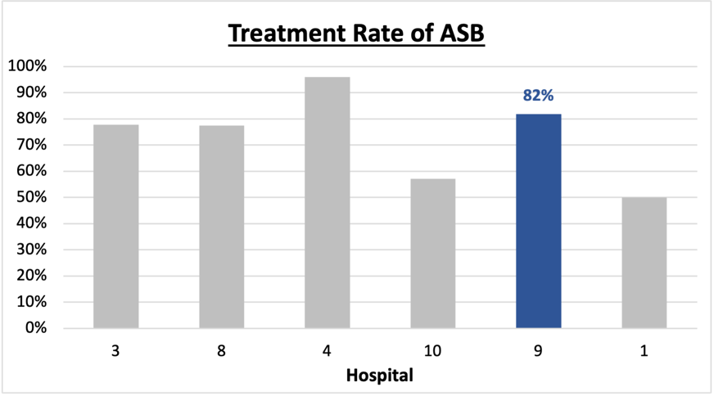**Prevalence and Treatment Rate of ASB**

**Treatment Rate**

**of ASB:**

**Prevalence of ASB:**

$$\frac{Number of treated ASB cases}{Number of ASB cases}$$

$$\frac{Number of ASB cases}{Number of positive urine cultures}$$

Data submissions

Total cases (positive urine cultures) included for your site: 28

Cases included per month for your site (median & IQR): 5.5 (3.5 – 6)

Prevalence of ASB

Prevalence of ASB across hospitals: 204 of 483 (42.2%)

Prevalence of ASB at your site: 11 of 28 (39.3%)

Treatment Rate of ASB

Treatment rate of ASB in overall cohort: 164 of 204 (80.4%)

Treatment rate of ASB at your site: 9 of 11 (81.8%)

Previous treatment rate at your site (from ASB 101 cohort): 16 of 16 (100%)

**Antibiotic Tables**

| **Table 1: Three Most Common Antibiotics comparing UTI & ASB** | | | |
| --- | --- | --- | --- |
| **IV** | | **Oral** | |
| **UTI, n= 3** | **ASB, n = 5** | **UTI, n=14** | **ASB, n = 8** |
| Ceftriaxone (n=3) | Ceftriaxone (n=5) | Nitrofurantoin (n=5) | Cephalexin (n=4) |
| NA | NA | Cephalexin (n=4) | Ciprofloxacin (n=2) |
| NA | NA | Amoxicillin-clavulanate (n=1) | Nitrofurantoin (n=1) |

| **Table 2: Antibiotic Duration (days)** | **UTI** | | **ASB** | |
| --- | --- | --- | --- | --- |
| **Prior, n=17** | **This Month, n=0** | **Prior, n= 9** | **This Month, n=2** |
| Total Antibiotic Duration; median (IQR) | 7 (3-7) | NA | 7 (3-7) | 3.5 (1.75-5.25) |
| Number of Cases Receiving >7 days; n (%) | 4 (23.5%) | NA | 1 (11.1%) | 0 |

Prior is Sept 2023 - Feb 2024 & this month is March 2024

| **Table 3: Characteristics comparing this month to prior n (%)** | **UTI** | | **ASB** | |
| --- | --- | --- | --- | --- |
| **Prior, n=17** | **This Month, n=0** | **Prior, n=9** | **This Month, n=2** |
| **Setting where culture obtained** | | | | |
| ED, then admitted | 1 (5.9%) | 0 | 3 (33.3%) | 0 |
| ED, then discharged | 5 (29.4%) | 0 | 6 (66.7%) | 2 (100%) |
| Ambulatory care clinic | 5 (29.4%) | 0 | 0 | 0 |
| Inpatient | 0 | 0 | 0 | 0 |
| Other | 6 (35.3%) | 0 | 0 | 0 |
| From reflex test | 8 (47.1%) | 0 | 7 (77.8%) | 2 (100%) |
| Men | 3 (17.6%) | 0 | 5 (55.6%) | 0 |
| Age >75 | 7 (41.2%) | 0 | 5 (55.6%) | 1 (50%) |
| Acute altered mental status changes alone | 1 (5.9%) | 0 | 3 (33.3%) | 0 |

**Characteristic Tables**

Prior is Sept 2023 - Feb 2024 & this month is March 2024

|  |  |  |  |  |
| --- | --- | --- | --- | --- |
| **Table 4: Prescribing Characteristics** | **UTI** | | **ASB** | |
| **Prior, n=17** | **This Month, n= 0** | **Prior, n=9** | **This Month, n=2** |
| **Top 3 Prescriber IDs (if available)** | | | |  |
|  | 46020 (n=3) |  | 10102 (n=3) | 10145 (n=2) |
| 10102 (n=2) |  | 10147 (n=2) |  |
| 10169 (n=2) |  | 89377 (n=2) |  |
| **Prescriber type, n (%)** | | | |  |
| Physician | 11 (64.7%) | 0 | 9 (100%) | 2 (100%) |
| Physician Assistant | 5 (29.4%) | 0 | 0 | 0 |
| Nurse Practitioner | 1 (5.9%) | 0 | 0 | 0 |
| **Contract of prescribing provider, n (%) (if available)** | | | |  |
| Employed by hospital | 12 (75%) | 0 | 6 (66.7%) | 2 (100%) |
| Contracted from outside group/locum | 4 (25%) | 0 | 1 (11.1%) | 0 |
| Not sure | 0 | 0 | 2 (22.2%) | 0 |

Prior is Sept 2023 - Feb 2024 & this month is March 2024

**Case IDs for the treated ASB cases**

130322290" "130322417" "130322439" "130324126" "130336310" "130336461"

"130338192" "130340072" "130344012"

**Key Terms and Definitions**

* Positive urine culture: Any growth on culture
  + Prevalence of ASB: A positive urine culture without any documented signs or symptoms attributable to urinary tract infection per National Hospital Safety Network (NHSN) and Infectious Diseases Society of America (IDSA) Guidelines.
* Signs or symptoms of UTI includes:
* Fever (>38°C)
* Suprapubic tenderness
* Costovertebral angle pain or tenderness
* Urinary urgency
* Urinary frequency
* Dysuria
* Altered Mental Status + 2 or more SIRS criteria
* Treatment rate of ASB: antibiotic treatment for ASB

**Action items/Insight**:

Based on the Inappropriate Diagnosis of UTI Measure, your hospital is a performing **above average** in terms of percentage of UTI cases that were actually ASB. Please continue to try and work on improving this. Additional comments:

**Positives to Highlight**:

* **Met case submission requirement:** Great job submitting cases! Celebrate this success!
* **Overall, down trend in ASB treatment rate:** Throughout the year, your treatment rate of ASB has trended down. In IQIC 101 and the first data report, your treatment rate was 100%. Although this number is high, you have decreased to it to 82%. Work to maintain this momentum!
* **High nitrofurantoin and cephalosporin use:** Less harmful/more narrow therapy use is high at your site! Great job! Minimal fluoroquinolone use on the report is awesome.

**Areas of Improvement**:

* **Up-trending Diagnosis of UTI Measure:** Throughout quality improvement work, it is important to recognize that valleys and peaks occur within this process. When reflecting on prior rates at your facility, please celebrate that this is a huge improvement in overall process. However, this could be an opportunity to investigate what was done differently in Jan/March 2024 to contribute to this.