Trios Asymptomatic Bacteriuria (ASB) Report
Date of Report: April 2024*
*This data report is based on cases submitted from September 2023 – March 2024 and does not include previous data.
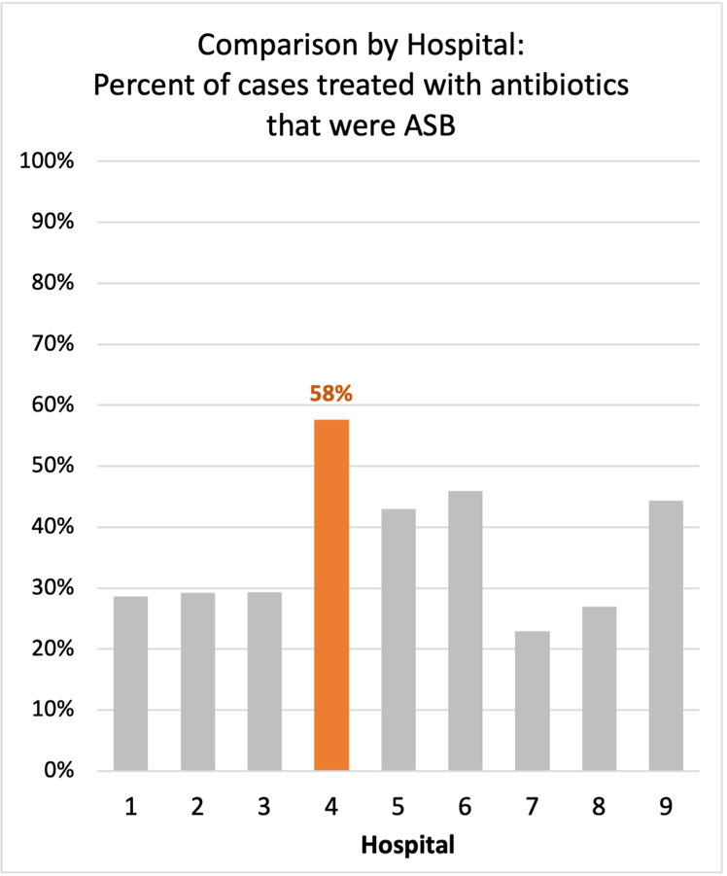
Inappropriate Diagnosis of UTI measure
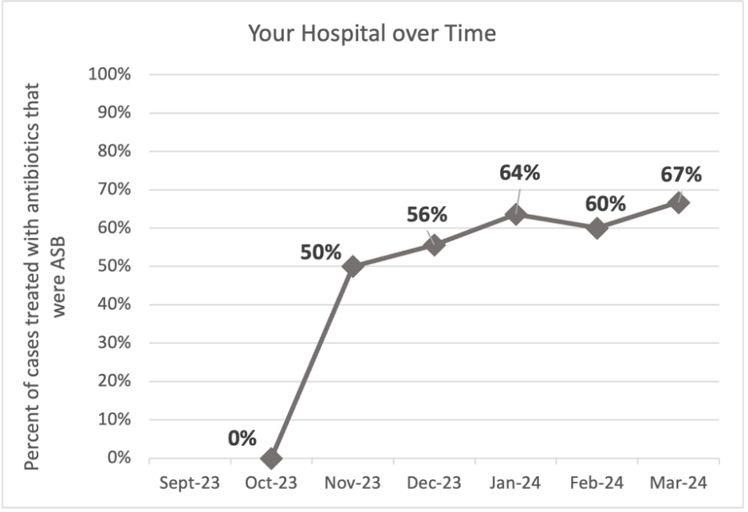
Average across hospitals in cohort: 34.5% ; HMS Hospital Average*: 23.2%
Inappropriate Diagnosis of UTI measure: $\frac{Number of patients treated for ASB}{Number of positive urine cultures treated (UTI+ASB)}$
- Goal: lower % = better
- You can lower this number by either reducing unnecessary urine cultures (diagnostic stewardship) or reducing antibiotic treatment when unnecessary cultures are obtained (antibiotic stewardship)
*The HMS hospital average was amongst 46 hospitals in the Michigan Hospital Medicine Safety Consortium that participated in a similar quality improvement study.

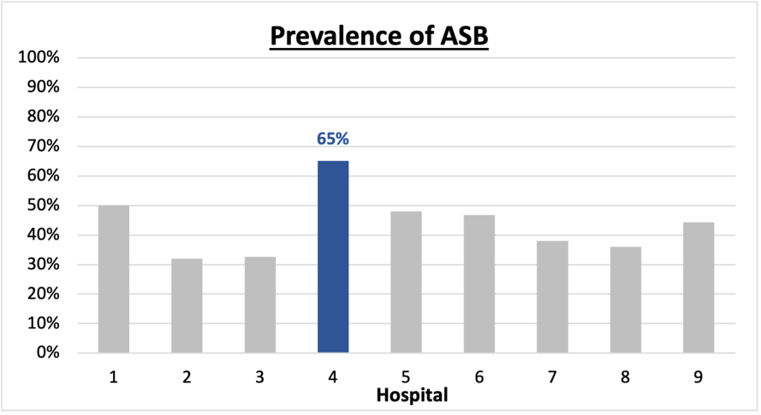
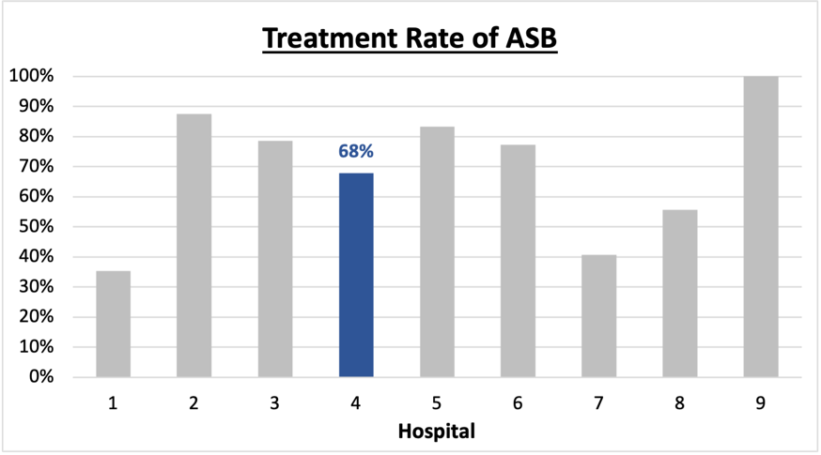
Prevalence and Treatment Rate of ASB
Prevalence of ASB:
$$\frac{Number of ASB cases}{Number of positive urine cultures}$$
$$\frac{Number of treated ASB cases}{Number of ASB cases}$$
Treatment Rate
of ASB:

Data submissions
Total cases (positive urine cultures) included for your site: 43
Cases included per month for your site (median & IQR): 6.5 (6-9.25)

Prevalence of ASB
Prevalence of ASB across hospitals: 164 of 390 (42.1%)
Prevalence of ASB at your site: 28 of 43 (65.1%)

Treatment Rate of ASB
Treatment rate of ASB in overall cohort: 106 of 164 (64.6%)
Treatment rate of ASB at your site: 19 of 28 (67.9%)

Antibiotic Tables
Table 1: Three Most Common Antibiotics comparing UTI & ASB
IV |  | Oral
UTI, n=8 | ASB, n = 18 | UTI, n=13 | ASB, n = 14
Ceftriaxone (n=6) | Ceftriaxone (n=15) | Nitrofurantoin (n=4) | Cephalexin (n=7)
Levofloxacin (n=1) | Cefepime (n=1) | Cephalexin (n=3) | Nitrofurantoin (n=3)
Pip-Tazo (n=1) | Meropenem (n=1) | Cefdinir (n=2) | Cefdinir (n=2)
Table 2: Antibiotic Duration (days) | UTI |  | ASB
 | Prior, n=15 | This Month, n=1 | Prior, n=23 | This Month, n=5
Total Antibiotic Duration; median (IQR) | 5 (4-9) | 6 (6-6) | 5 (0.5-10.5) | 1 (0-5)
Number of Cases Receiving >7 days; n (%) | 6 (40%) | 0 | 9 (39.1%) | 1 (20%)

Prior is Sept 2023 - Feb 2024 & this month is March 2024
Table 3: Characteristics comparing this month to prior n (%) | UTI |  | ASB
 | Prior, n=15 | This Month, n=1 | Prior, n=23 | This Month, n=5
Setting where culture obtained
ED, then admitted | 2 (13.3%) | 0 | 3 (13.0%) | 0
ED, then discharged | 11 (73.3%) | 1 (100%) | 18 (78.3%) | 4 (80%)
Ambulatory care clinic | 0 | 0 | 0 | 0
Inpatient | 2 (13.3%) | 0 | 2 (8.7%) | 1 (20%)
Other | 0 | 0 | 0 | 0
From reflex test | 14 (93.3%) | 1 (100%) | 23 (100%) | 5 (100%)
Men | 4 (26.7%) | 0 | 10 (43.5%) | 0
Age >75 | 2 (13.3%) | 0 | 10 (43.5%) | 2 (40%)
Acute altered mental status changes alone | 2 (13.3%) | 0 | 3 (13.0%) | 0
Characteristic Tables
Prior is Sept 2023 - Feb 2024 & this month is March 2024

Table 4: Prescribing Characteristics | UTI |  | ASB
 | Prior, n=15 | This Month, n=1 | Prior, n=23 | This Month, n=5
Top 3 Prescriber IDs (if available)
 | PH021 (n=5) | PH027 (n=1) | PH038 (n=6) | PH015 (n=1)
 | PH032 (n=2) | NA | PH002 (n=4) | PH020 (n=1)
 | PH035 (n=2) | NA | PH021 (n=4) | PH027 (n=1)
Prescriber type, n (%)
Physician | 11 (73.3%) | 1 (100%) | 18 (78.3%) | 3 (60%)
Physician Assistant | 2 (13.3%) | 0 | 3 (13.0%) | 1 (20%)
Nurse Practitioner | 2 (13.3%) | 0 | 2 (8.7%) | 1 (20%)
Contract of prescribing provider, n (%) (if available)
Employed by hospital | 2 (13.3%) | 0 | 2 (8.7%) | 1 (20%)
Contracted from outside group/locum | 13 (86.7%) | 1 (100%) | 21 (91.3%) | 4 (80%)
Not sure | 0 | 0 | 0 | 0
Prior is Sept 2023 - Feb 2024 & this month is March 2024
Case IDs for the treated ASB cases
"TSH0009" "TSH0016" "TSH0021" "TSH0026" "TSH0031" "TSH0034" "TSH0036"
"TSH0042" "TSH0044" "TSH0045" "TSH0047" "TSH0049" "TSH0054" "TSH0055"
"TSH0060" "TSH0063" "TSH0073" "TSH0079" "TSH0081"

Key Terms and Definitions
- Positive urine culture: Any growth on culture
  - Prevalence of ASB: A positive urine culture without any documented signs or symptoms attributable to urinary tract infection per National Hospital Safety Network (NHSN) and Infectious Diseases Society of America (IDSA) Guidelines.
- Signs or symptoms of UTI includes:
- Fever (>38°C)
- Suprapubic tenderness
- Costovertebral angle pain or tenderness
- Urinary urgency
- Urinary frequency
- Dysuria
- Altered Mental Status + 2 or more SIRS criteria
- Treatment rate of ASB: antibiotic treatment for ASB

Action items/Insight:
Based on the Inappropriate Diagnosis of UTI Measure, your hospital is a performing below average in terms of percentage of UTI cases that were actually ASB. Please continue to try and work on improving this. Additional comments:
- Met case submission requirement: Great job submitting cases! Celebrate this success!
- Low Fluoroquinolone use: Fluoroquinolone use appears to be low at your site! Great job!
- Downtrending treatment duration: Treatment duration for both UTI and ASB were initially high, with approximately 40% of cases receiving >7d of therapy prior to the final month of data collection. However, it appears this percentage is starting to trend down for both UTI and ASB during the last month of data collection. Great job! Keep working on this, as this is likely to be a high-yield area of intervention.
- High Treatment of ASB: Among patients that have ASB, your clinicians have a high likelihood of treating (67.9%), and this appears to be increasing (based on the inappropriate diagnosis of UTI measure trend). We would recommend focusing on this. If convincing clinicians to stop prescribing antibiotics for ASB is a challenge at your hospital, it might be easier to suggest shorter durations (eg. 3 days) or less harmful/more narrow therapy (eg. Nitrofurantoin) for patients without symptoms. This might be a compromise or intermediate step to help clinicians feel more comfortable with less antibiotics for these patients.

