Pullman Asymptomatic Bacteriuria (ASB) Report
Date of Report: April 2024*
*This data report is based on cases submitted from September 2023 – March 2024 and does not include previous data.
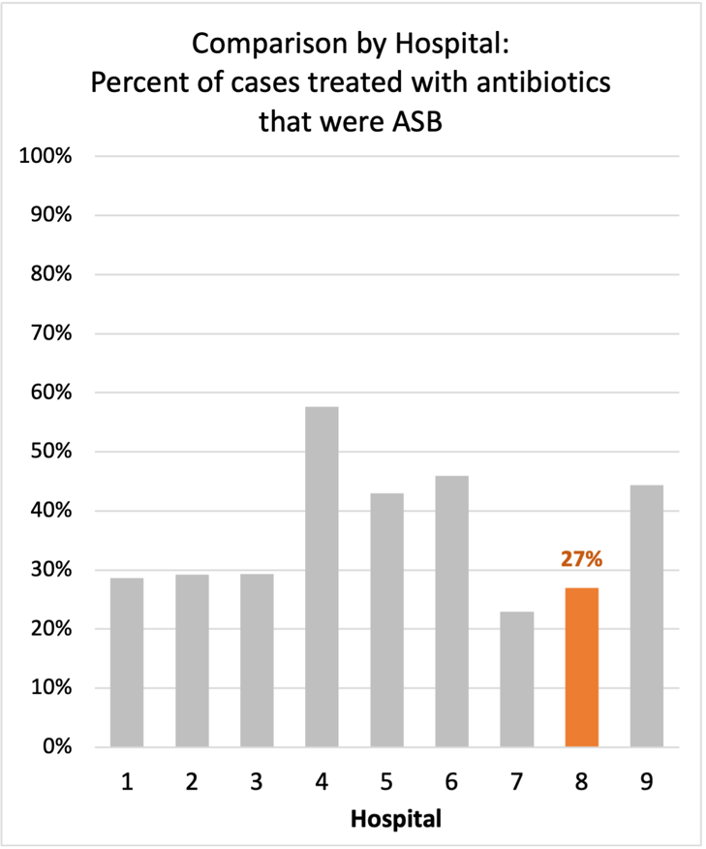
Inappropriate Diagnosis of UTI measure
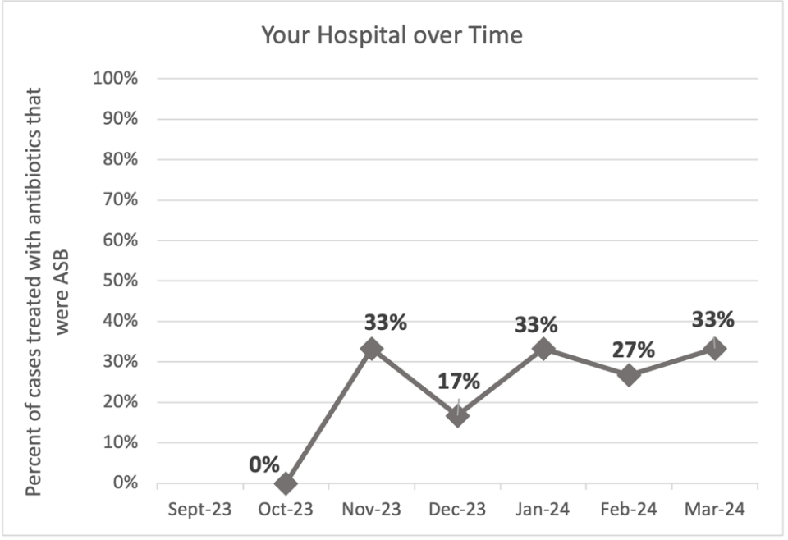
Average across hospitals in cohort: 34.5% ; HMS Hospital Average*: 23.2%
Inappropriate Diagnosis of UTI measure: $\frac{Number of patients treated for ASB}{Number of positive urine cultures treated (UTI+ASB)}$
- Goal: lower % = better
- You can lower this number by either reducing unnecessary urine cultures (diagnostic stewardship) or reducing antibiotic treatment when unnecessary cultures are obtained (antibiotic stewardship)
*The HMS hospital average was amongst 46 hospitals in the Michigan Hospital Medicine Safety Consortium that participated in a similar quality improvement study.

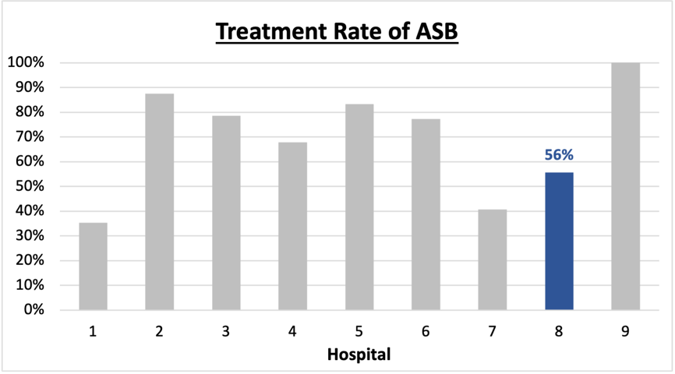
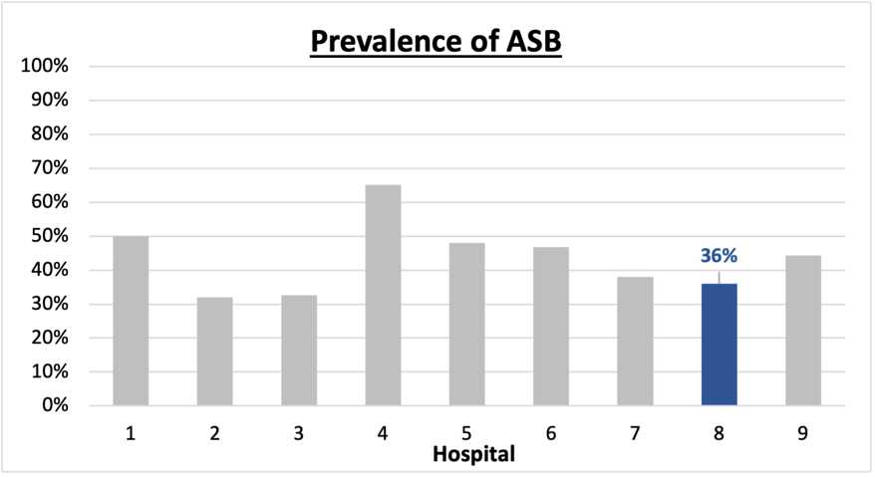
Prevalence and Treatment Rate of ASB
Prevalence of ASB:
$$\frac{Number of treated ASB cases}{Number of ASB cases}$$
Treatment Rate
of ASB:

$$\frac{Number of ASB cases}{Number of positive urine cultures}$$

Data submissions
Total cases (positive urine cultures) included for your site: 50
Cases included per month for your site (median & IQR): 7.5 (5.25-10.5)

Prevalence of ASB
Prevalence of ASB across hospitals: 164 of 390 (42.1%)
Prevalence of ASB at your site: 18 of 50 (36%)

Treatment Rate of ASB
Treatment rate of ASB in overall cohort: 106 of 164 (64.6%)
Treatment rate of ASB at your site: 10 of 18 (55.6%)

Antibiotic Tables
Table 1: Three Most Common Antibiotics comparing UTI & ASB
IV |  | Oral
UTI, n=4 | ASB, n=4 | UTI, n=29 | ASB, n=10
Ceftriaxone (n=4) | Ceftriaxone (n=3) | Nitrofurantoin (n=12) | Cefdinir (n=4)
NA | Cefazolin (n=1) | Tri-sulfa (n=6) | Cephalexin (n=2)
NA | NA | Cephalexin (n=5) | Nitrofurantoin (n=2)
Table 2: Antibiotic Duration (days) | UTI |  | ASB
 | Prior, n=29 | This Month, n=3 | Prior, n=15 | This Month, n=3
Total Antibiotic Duration; median (IQR) | 5 (3-7.5) | 7 (3.5-7.5) | 3 (0-7) | 0 (0-4)
Number of Cases Receiving >7 days; n (%) | 6 (20.7%) | 1 (33.3%) | 2 (13.3%) | 1 (33.3%)

Prior is Sept 2023 - Feb 2024 & this month is March 2024
Table 3: Characteristics comparing this month to prior n (%) | UTI |  | ASB
 | Prior, n=29 | This Month, n=3 | Prior, n=15 | This Month, n=3
Setting where culture obtained
ED, then admitted | 1 (3.4%) | 0 | 5 (33.3%) | 0
ED, then discharged | 13 (44.8%) | 3 (100%) | 6 (40%) | 2 (66.7%)
Ambulatory care clinic | 15 (51.7%) | 0 | 3 (20%) | 1 (33.3%)
Inpatient | 0 | 0 | 1 (6.7%) | 0
Other | 0 | 0 | 0 | 0
From reflex test | 0 | 0 | 0 | 0
Men | 8 (27.6%) | 0 | 2 (13.3%) | 0
Age >75 | 5 (17.2%) | 0 | 7 (46.7%) | 1 (33.3%)
Acute altered mental status changes alone | 1 (3.4%) | 0 | 0 | 2 (66.7%)
Characteristic Tables
Prior is Sept 2023 - Feb 2024 & this month is March 2024

Table 4: Prescribing Characteristics | UTI |  | ASB
 | Prior, n=29 | This Month, n=3 | Prior, n=15 | This Month, n=3
Top 3 Prescriber IDs (if available)
 | 17 (n=6) | 17 (n=1) | 10 (n=3) | 14 (n=1)
 | 7 (n=4) | 19 (n=1) | 6 (n=3) | 17 (n=1)
 | 11 (n=2) | 26 (n=1) | 2 (n=2) | 19 (n=1)
Prescriber type, n (%)
Physician | 25 (86.2%) | 3 (100%) | 15 (100%) | 3 (100%)
Physician Assistant | 4 (13.8%) | 0 | 0 | 0
Nurse Practitioner | 0 | 0 | 0 | 0
Contract of prescribing provider, n (%) (if available)
Employed by hospital | 29 (100%) | 3 (100%) | 14 (93.3%) | 3 (100%)
Contracted from outside group/locum | 0 | 0 | 1 (6.7%) | 0
Not sure | 0 | 0 | 0 | 0
Prior is Sept 2023 - Feb 2024 & this month is March 2024
Case IDs for the treated ASB cases
"1121232" "105243" "119241" "119243" "206243" "206246" "216246" "304244" "304245" "401242"

Key Terms and Definitions
- Positive urine culture: Any growth on culture
  - Prevalence of ASB: A positive urine culture without any documented signs or symptoms attributable to urinary tract infection per National Hospital Safety Network (NHSN) and Infectious Diseases Society of America (IDSA) Guidelines.
- Signs or symptoms of UTI includes:
- Fever (>38°C)
- Suprapubic tenderness
- Costovertebral angle pain or tenderness
- Urinary urgency
- Urinary frequency
- Dysuria
- Altered Mental Status + 2 or more SIRS criteria
- Treatment rate of ASB: antibiotic treatment for ASB

Action items/Insight:
Based on the Inappropriate Diagnosis of UTI Measure, your hospital is a performing above average in terms of percentage of UTI cases that were actually ASB. Please continue to try and work on improving this. Additional comments:
- Met case submission requirement: Great job submitting cases! Celebrate this success!
- Low Fluoroquinolone use: Fluoroquinolone use appears to be low at your site! Great job!
- Downtrending treatment duration for ASB: Treatment duration for ASB is starting to trend down. Great job! Keep working on this.
- High treatment duration for UTI: Your median treatment duration for UTI during the last month was 7 days (though in prior months, the median was 5 days) – and a significant number of patients receive >7 days (20.7 to 33.3% over the course of the study period). This is an area on which you could focus to help reduce overall antibiotic use.

