Lower Umpqua Asymptomatic Bacteriuria (ASB) Report
Date of Report: April 2024*
*This data report is based on cases submitted from September 2023 – March 2024 and does not include previous data.
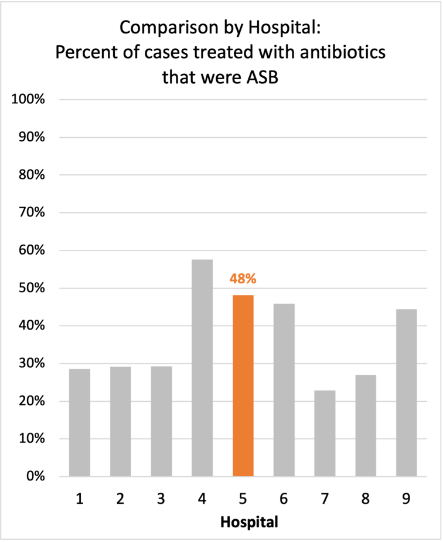
Inappropriate Diagnosis of UTI measure
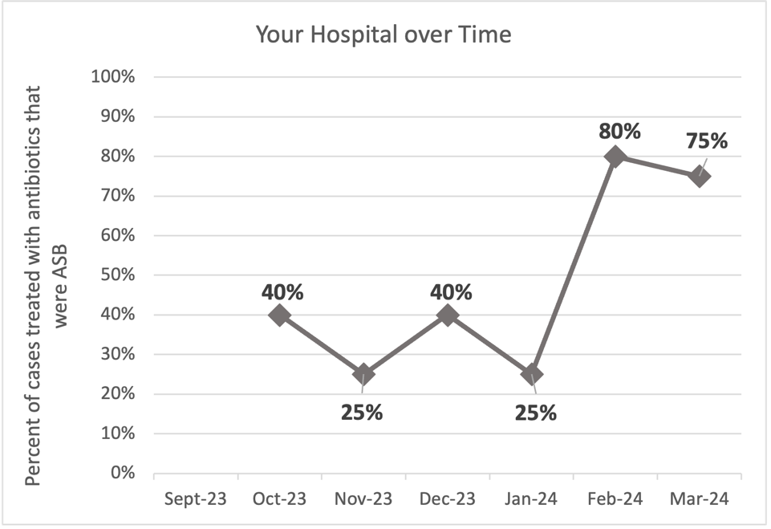
Average across hospitals in cohort: 34.5% ; HMS Hospital Average*: 23.2%
Inappropriate Diagnosis of UTI measure: $\frac{Number of patients treated for ASB}{Number of positive urine cultures treated (UTI+ASB)}$
- Goal: lower % = better
- You can lower this number by either reducing unnecessary urine cultures (diagnostic stewardship) or reducing antibiotic treatment when unnecessary cultures are obtained (antibiotic stewardship)
*The HMS hospital average was amongst 46 hospitals in the Michigan Hospital Medicine Safety Consortium that participated in a similar quality improvement study.

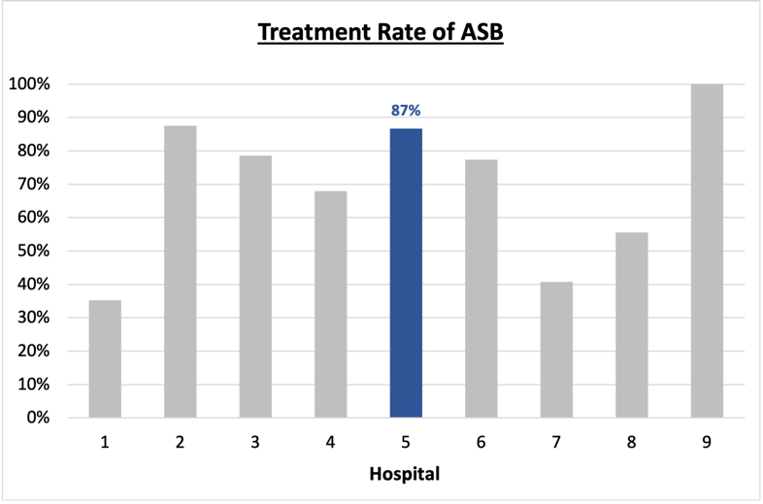
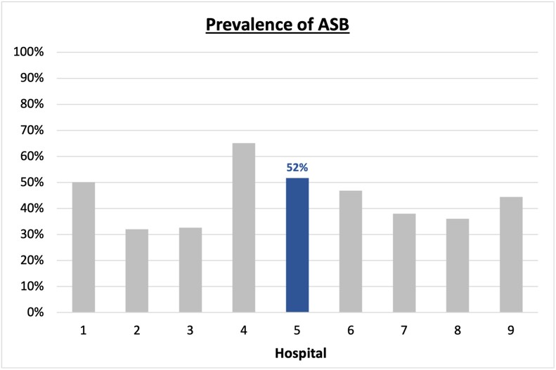
Prevalence and Treatment Rate of ASB
Prevalence of ASB:
$$\frac{Number of treated ASB cases}{Number of ASB cases}$$
Treatment Rate
of ASB:

$$\frac{Number of ASB cases}{Number of positive urine cultures}$$

Data submissions
Total cases (positive urine cultures) included for your site: 29
Cases included per month for your site (median & IQR): 4.5 (4-5)

Prevalence of ASB
Prevalence of ASB across hospitals: 164 of 390 (42.1%)
Prevalence of ASB at your site: 15 of 29 (51.7%)

Treatment Rate of ASB
Treatment rate of ASB in overall cohort: 106 of 164 (64.6%)
Treatment rate of ASB at your site: 13 of 15 (86.7%)

Antibiotic Tables
Table 1: Three Most Common Antibiotics comparing UTI & ASB
IV |  | Oral
UTI, n= 3 | ASB, n = 8 | UTI, n=15 | ASB, n = 11
Ceftriaxone (n=3) | Ceftriaxone (n=4) | Nitrofurantoin (n=5) | Nitrofurantoin (n=3)
NA | Pip-tazo (n=1) | Tri-sulfa (n=4) | Cephalexin (n=3)
NA | Vancomycin (n=1) | Amoxicillin (n=2) | Cefpodoxime (n=2)
Table 2: Antibiotic Duration (days) | UTI |  | ASB
 | Prior, n=13 | This Month, n=1 | Prior, n=12 | This Month, n=3
Total Antibiotic Duration; median (IQR) | 7 (5-10) | 5 (5-5) | 4 (2.75-7) | 7 (4-9.5)
Number of Cases Receiving >7 days; n (%) | 6 (46.2%) | 0 | 2 (16.7%) | 1 (33.3%)

Prior is Sept 2023 – Jan 2024 & this month is March 2024
Table 3: Characteristics comparing this month to prior n (%) | UTI |  | ASB
 | Prior, n=13 | This Month, n=1 | Prior, n=12 | This Month, n=3
Setting where culture obtained
ED, then admitted | 0 | 0 | 2 (16.7%) | 0
ED, then discharged | 3 (23.1%) | 0 | 8 (66.7%) | 2 (66.7%)
Ambulatory care clinic | 4 (30.8%) | 0 | 0 | 0
Inpatient | 0 | 0 | 2 (16.7%) | 1 (33.3%)
Other | 6 (46.2%) | 1 (100%) | 0 | 0
From reflex test | 7 (53.8%) | 0 | 11 (91.7%) | 3 (100%)
Men | 4 (30.8%) | 0 | 3 (25%) | 1 (33.3%)
Age >75 | 5 (38.5%) | 0 | 6 (50%) | 0
Acute altered mental status changes alone | 0 | 0 | 1 (8.3%) | 1 (33.3%)
Characteristic Tables
Prior is Sept 2023 - Jan 2024 & this month is March 2024

Table 4: Prescribing Characteristics | UTI |  | ASB
 | Prior, n=13 | This Month, n=1 | Prior, n=12 | This Month, n=3
Top 3 Prescriber IDs (if available)
 | 2 ( n=6) | 2 (n=1) | 1 (n=5) | 3 (n=1)
 | 22 (n=2) | 0 | 3 (n=3) | 4 (n=1)
 | 3 (n=2) | 0 | 11 (n=2) | 8 (n=1)
Prescriber type, n (%)
Physician | 11 (84.6%) | 1 (100%) | 12 (100%) | 3 (100%)
Physician Assistant | 0 | 0 | 0 | 0
Nurse Practitioner | 2 (15.4%) | 0 | 0 | 0
Contract of prescribing provider, n (%) (if available)
Employed by hospital | 10 (76.9%) | 1 (100%) | 4 (33.3%) | 1 (33.3%)
Contracted from outside group/locum | 3 (23.1%) | 0 | 8 (66.7%) | 2 (66.7%)
Not sure | 0 | 0 | 0 | 0
Prior is Sept 2023 - Jan 2024 & this month is March 2024
Case IDs for the treated ASB cases
"4" "7" "6" "11" "12" "20" "27" "29" "34" "35" "37" "39" "40"

Key Terms and Definitions
- Positive urine culture: Any growth on culture
  - Prevalence of ASB: A positive urine culture without any documented signs or symptoms attributable to urinary tract infection per National Hospital Safety Network (NHSN) and Infectious Diseases Society of America (IDSA) Guidelines.
- Signs or symptoms of UTI includes:
- Fever (>38°C)
- Suprapubic tenderness
- Costovertebral angle pain or tenderness
- Urinary urgency
- Urinary frequency
- Dysuria
- Altered Mental Status + 2 or more SIRS criteria
- Treatment rate of ASB: antibiotic treatment for ASB

Action items/Insight:
Based on the Inappropriate Diagnosis of UTI Measure, your hospital is a performing below average in terms of percentage of UTI cases that were actually ASB. Please continue to try and work on improving this. Additional comments:
- Met case submission requirement: Great job submitting cases! Celebrate this success!
- High Treatment of ASB: Among the patients that have ASB, your clinicians are still showing a tendency to treat (83.3%). Would recommend focusing on this. If convincing clinicians to stop prescribing antibiotics for ASB is a challenge at your hospital, it might be easier to suggest shorter durations (eg. 3 days) for patients without symptoms. This might be a compromise or intermediate step to help clinicians be comfortable with less antibiotics for these patients.
- High Treatment Rate with Preferred Antibiotics: Among patients with both UTI and ASB, nitrofurantoin, trimethoprim-sulfamethoxazole, and narrow-spectrum beta-lactams (amoxicillin, cephalexin) are most common. Notably, fluoroquinolones (like ciprofloxacin and levofloxacin) are not highly-utilized agents – this is worth celebrating!
- Long Treatment Duration: Treatment duration for UTI remains high (with 50% of cases receiving more than 7d of therapy from Sept 2023 – Jan 2024). This is an area on which you could focus to help reduce overall antibiotic use. Notably, the treatment duration appears shorter for cases of ASB.

