Coulee Asymptomatic Bacteriuria (ASB) Report
Date of Report: July 2024*
*This data report is based on cases submitted from September 2023 – June 2024 and does not include previous data.
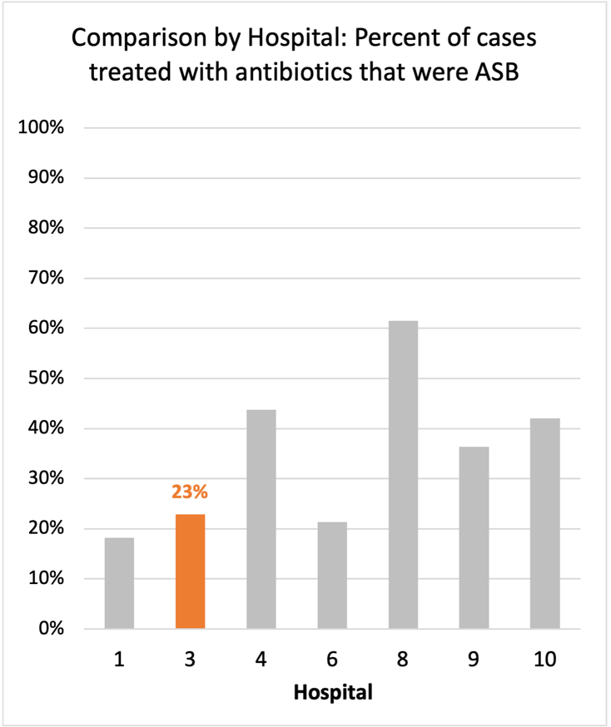
Inappropriate Diagnosis of UTI measure
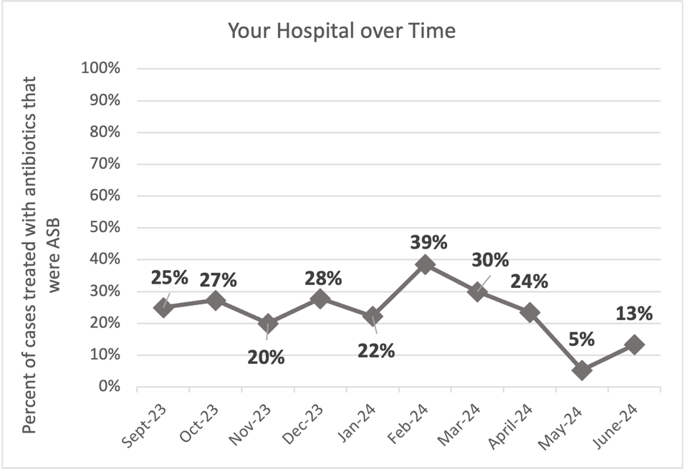
Average across hospitals in cohort: 35.6% ; HMS Hospital Average*: 23.2%
Inappropriate Diagnosis of UTI measure: $\frac{Number of patients treated for ASB}{Number of positive urine cultures treated (UTI+ASB)}$
- Goal: lower % = better
- You can lower this number by either reducing unnecessary urine cultures (diagnostic stewardship) or reducing antibiotic treatment when unnecessary cultures are obtained (antibiotic stewardship)
*The HMS hospital average was amongst 46 hospitals in the Michigan Hospital Medicine Safety Consortium that participated in a similar quality improvement study.

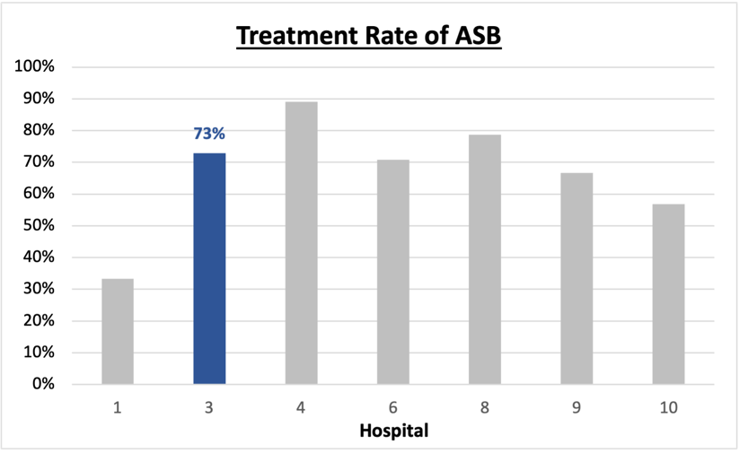
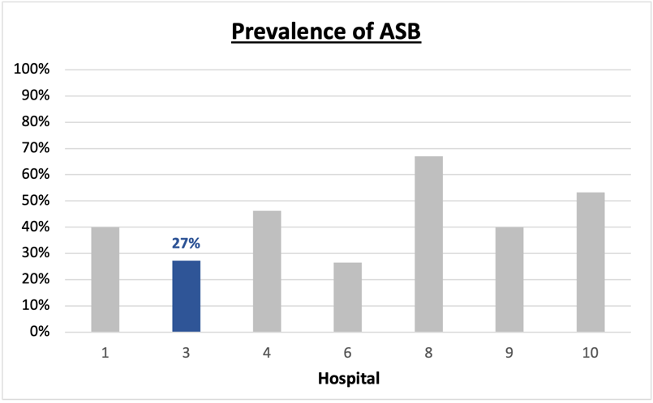
Prevalence and Treatment Rate of ASB

$$\frac{Number of ASB cases}{Number of positive urine cultures}$$
Prevalence of ASB:
$$\frac{Number of treated ASB cases}{Number of ASB cases}$$
Treatment Rate
of ASB:

Data submissions
Total cases (positive urine cultures) included for your site: 176
Cases included per month for your site (median & IQR): 17 (16-20)

Prevalence of ASB
Prevalence of ASB across hospitals: 356 of 868 (41.0%)
Prevalence of ASB at your site: 48 of 176 (27.3%)

Treatment Rate of ASB
Treatment rate of ASB in overall cohort: 266 of 356 (74.7%)
Treatment rate of ASB at your site: 35 of 48 (72.9%)
Previous treatment rate at your site (from ASB 101 cohort): 27 of 32 (84%)

Antibiotic Tables
Table 1: Three Most Common Antibiotics comparing UTI & ASB
IV |  | Oral
UTI, n = 6 | ASB, n = 7 | UTI, n = 125 | ASB, n =35
Ceftriaxone (n=6) | Ceftriaxone (n=7) | Nitrofurantoin (n=74) | Nitrofurantoin (n=19)
 |  | Trim-sulfa (n=24) | Ciprofloxacin (n=4)
 |  | Cephalexin (n=7) | Trim-sulfa (n=4)
Table 2: Antibiotic Duration (days) | UTI |  | ASB
 | Prior, n=114 | This Month, n=14 | Prior, n=45 | This Month, n=3
Total Antibiotic Duration; median (IQR) | 5 (5-7) | 5 (3.5-5) | 5 (0-7) | 5 (2.5-5)
Number of Cases Receiving >7 days; n (%) | 18 (15.8%) | 1 (7.1%) | 8 (17.8%) | 0 (0%)

Prior is Sept 2023 - May 2024 & this month is June 2024
Table 3: Characteristics comparing this month to prior n (%) | UTI |  | ASB
 | Prior, n=114 | This Month, n=14 | Prior, n=45 | This Month, n=3
Setting where culture obtained
ED, then admitted | 1 (0.9%) | 0 | 3 (6.7%) | 0
ED, then discharged | 21 (18.4%) | 4 (28.6%) | 26 (57.7%) | 2 (66.6%)
Ambulatory care clinic | 92 (80.7%) | 10 (71.4%) | 15 (33.3%) | 1 (33.3%)
Inpatient | 0 | 0 | 1 (2.2%) | 0
Other | 0 | 0 | 0 | 0
From reflex test | 33 (28.9%) | 4 (28.6%) | 33 (73.3%) | 3 (100%)
Men | 14 (12.3%) | 2 (14.3%) | 14 (31.1%) | 0
Age >75 | 31 (27.2%) | 2 (14.3%) | 12 (26.7%) | 0
Acute altered mental status changes alone | 0 | 0 | 5 (11.1%) | 0
Characteristic Tables
Prior is Sept 2023 - May 2024 & this month is June 2024
Table 4: Prescribing Characteristics | UTI |  | ASB
 | Prior, n=114 | This Month, n=14 | Prior, n=45 | This Month, n=3
Top 3 Prescriber IDs (if available)
 | H (n=72) | H (n=10) | H (n=12) | A (n=1)
 | E (n=6) | A (n=1) | K (n=9) | E (n=1)
 | K (n=6) | E (n=1) | B (n=6) | J (n=1)
Prescriber type, n (%)
Physician | 13 (11.4%) | 1 (7.1%) | 10 (22.2%) | 2 (66.7%)
Physician Assistant | 8 (7.0%) | 2 (14.3%) | 9 (20%) | 1 (33.3%)
Nurse Practitioner | 93 (81.6%) | 11 (78.6%) | 26 (57.8%) | 0
Contract of prescribing provider, n (%) (if available)
Employed by hospital | 36 (31.6%) | 3 (21.4%) | 28 (62.2%) | 3 (100%)
Contracted from outside group/locum | 78 (68.4%) | 11 (78.6%) | 17 (37.8%) | 0
Not sure | 0 | 0 | 0 | 0

Prior is Sept 2023 - May 2024 & this month is June 2024
Case IDs for the treated ASB cases
"#908" "#920" "#924" "#926" "#1000" "#1008" "#1013" "#1110" "#1121" "#1126" "1210" "1217" "1218" "1227" "1231"
"#0113" "#0114" "204" "213" "216" "218" "221" "306" "317" "318" "320" "321" "322" "403" "414" "415"
"436" "518" "529" "530"

Key Terms and Definitions
- Positive urine culture: Any growth on culture
  - Prevalence of ASB: A positive urine culture without any documented signs or symptoms attributable to urinary tract infection per National Hospital Safety Network (NHSN) and Infectious Diseases Society of America (IDSA) Guidelines.
- Signs or symptoms of UTI includes:
- Fever (>38°C)
- Suprapubic tenderness
- Costovertebral angle pain or tenderness
- Urinary urgency
- Urinary frequency
- Dysuria
- Altered Mental Status + 2 or more SIRS criteria
- Treatment rate of ASB: antibiotic treatment for ASB

Action items/Insight:
Based on the Inappropriate Diagnosis of UTI Measure, your hospital is a performing better than average in terms of percentage of UTI cases that were actually ASB.
Additional comments:
Positives to Highlight:
- Performing better than average in the inappropriate diagnosis of UTI measure: You site has decreased from 29% last report to 23% this report - this is a very positive trend! (Woohoo look at how nice that trend is since Feb 2024 (: ) Celebrate this success and maintain this momentum!
- Met case submission requirement: Great job submitting cases! Celebrate this success! (Sandy you rock).
- Low/trending down ASB treatment rate: Throughout the year, your percent of ASB cases treated with antibiotics has trended down (84% in IQIC 101, previous report was 78%, and now 73%). This is a very positive trend! Work to maintain this momentum!
- High nitrofurantoin use: Less harmful/more narrow therapy use is high at your site! Great job!
Areas of Improvement:
- ASB treatment rate of 73% and prevalence rate of 27%: I want to recognize that it is great that these numbers are improving, however, there is always still work to be done in these areas. For example, one in every 4 patients with a positive urine culture are still asymptomatic. Keep working on this but incredible work overall!

