|  |
| --- |
| **Coulee Asymptomatic Bacteriuria (ASB) Report**  Date of Report: April 2024*  *This data report is based on cases submitted from September 2023 – March 2024 and does not include previous data. |

**Inappropriate Diagnosis of UTI measure**

|  |
| --- |
| **Average across hospitals in cohort: 38.3% ; HMS Hospital Average*: 23.2%**  **Inappropriate Diagnosis of UTI measure: $\frac{Number of patients treated for ASB}{Number of positive urine cultures treated (UTI+ASB)}$**   * **Goal:** lower % = better * You can lower this number by either reducing unnecessary urine cultures **(diagnostic stewardship)** or reducing antibiotic treatment when unnecessary cultures are obtained **(antibiotic stewardship)**   *The HMS hospital average was amongst 46 hospitals in the Michigan Hospital Medicine Safety Consortium that participated in a similar quality improvement study. |
|  |
|  |

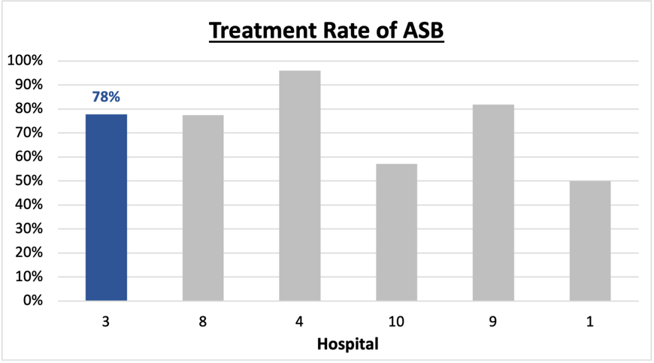**Prevalence and Treatment Rate of ASB**

$$\frac{Number of ASB cases}{Number of positive urine cultures}$$

**Prevalence of ASB:**

$$\frac{Number of treated ASB cases}{Number of ASB cases}$$

**Treatment Rate**

**of ASB:**

Data submissions

Total cases (positive urine cultures) included for your site: 114

Cases included per month for your site (median & IQR): 16 (14.5 – 18)

Prevalence of ASB

Prevalence of ASB across hospitals: 204 of 483 (42.2%)

Prevalence of ASB at your site: 36 of 114 (31.6%)

Treatment Rate of ASB

Treatment rate of ASB in overall cohort: 164 of 204 (80.4%)

Treatment rate of ASB at your site: 28 of 36 (77.8%)

Previous treatment rate at your site (from ASB 101 cohort): 27 of 32 (84%)

**Antibiotic Tables**

| **Table 1: Three Most Common Antibiotics comparing UTI & ASB** | | | |
| --- | --- | --- | --- |
| **IV** | | **Oral** | |
| **UTI, n= 5** | **ASB, n = 6** | **UTI, n= 72** | **ASB, n = 28** |
| Ceftriaxone (n=5) | Ceftriaxone (n=6) | Nitrofurantoin (n=46) | Nitrofurantoin (n=14) |
| NA | NA | Tri-sulfa (n=9) | Tri-sulfa (n=4) |
| NA | NA | Cephalexin (n=5) | Ciprofloxacin (n=3) |

| **Table 2: Antibiotic Duration (days)** | **UTI** | | **ASB** | |
| --- | --- | --- | --- | --- |
| **Prior, n=68** | **This Month, n=10** | **Prior, n=27** | **This Month, n=9** |
| Total Antibiotic Duration; median (IQR) | 5 (5-7) | 5 (5-5) | 6 (3-7) | 5 (0-7) |
| Number of Cases Receiving >7 days; n (%) | 13 (19.1%) | 1 (10%) | 6 (22.2%) | 2 (22.2%) |

Prior is Sept 2023 - Feb 2024 & this month is March 2024

| **Table 3: Characteristics comparing this month to prior n (%)** | **UTI** | | **ASB** | |
| --- | --- | --- | --- | --- |
| **Prior, n=68** | **This Month, n=10** | **Prior, n=27** | **This Month, n=9** |
| **Setting where culture obtained** | | | | |
| ED, then admitted | 1 (1.5%) | 0 | 2 (7.4%) | 1 (11.1%) |
| ED, then discharged | 16 (23.5%) | 1 (10%) | 16 (59.3%) | 5 (55.6%) |
| Ambulatory care clinic | 51 (75%) | 9 (90%) | 8 (29.6%) | 3 (33.3%) |
| Inpatient | 0 | 0 | 1 (3.7%) | 0 |
| Other | 0 | 0 | 0 | 0 |
| From reflex test | 27 (39.7%) | 1 (10%) | 21 (77.8%) | 7 (77.8%) |
| Men | 8 (11.8%) | 1 (10%) | 11 (40.7%) | 1 (11.1%) |
| Age >75 | 20 (29.4%) | 3 (30%) | 7 (25.9%) | 3 (33.3%) |
| Acute altered mental status changes alone | 0 | 0 | 5 (18.5%) | 0 |

**Characteristic Tables**

Prior is Sept 2023 - Feb 2024 & this month is March 2024

|  |  |  |  |  |
| --- | --- | --- | --- | --- |
| **Table 4: Prescribing Characteristics** | **UTI** | | **ASB** | |
| **Prior, n=68** | **This Month, n=10** | **Prior, n=27** | **This Month, n=9** |
| **Top 3 Prescriber IDs (if available)** | | | |  |
|  | H (n=42) | H (n=9) | H (n=7) | K (n=3) |
| E (n=6) | K (n=1) | B (n=4) | B (n=20 |
| K (n=4) |  | E (n=3) | H (n=2) |
| **Prescriber type, n (%)** | | | |  |
| Physician | 5 (7.4%) | 0 | 7 (25.9%) | 1 (11.1%) |
| Physician Assistant | 6 (8.8%) | 1 (10%) | 3 (11.1%) | 3 (33.3%) |
| Nurse Practitioner | 57 (83.8%) | 9 (90%) | 17 (63.0%) | 5 (55.6%) |
| **Contract of prescribing provider, n (%) (if available)** | | | |  |
| Employed by hospital | 22 (32.4%) | 1 (10%) | 17 (63.0%) | 6 (66.7%) |
| Contracted from outside group/locum | 46 (67.6%) | 9 (90%) | 10 (37.0%) | 3 (33.3%) |
| Not sure | 0 | 0 | 0 | 0 |

Prior is Sept 2023 - Feb 2024 & this month is March 2024

**Case IDs for the treated ASB cases**

"#908" "#920" "#924" "#926" "#1000" "#1008" "#1013" "#1110" "#1121"

"#1126" "1210" "1217" "1218" "1227" "1231" "#0113" "#0114" "204"

"213" "216" "218" "221" "306" "317" "318" "320" "321" "322"

**Key Terms and Definitions**

* Positive urine culture: Any growth on culture
  + Prevalence of ASB: A positive urine culture without any documented signs or symptoms attributable to urinary tract infection per National Hospital Safety Network (NHSN) and Infectious Diseases Society of America (IDSA) Guidelines.
* Signs or symptoms of UTI includes:
* Fever (>38°C)
* Suprapubic tenderness
* Costovertebral angle pain or tenderness
* Urinary urgency
* Urinary frequency
* Dysuria
* Altered Mental Status + 2 or more SIRS criteria
* Treatment rate of ASB: antibiotic treatment for ASB

**Action items/Insight**:

Based on the Inappropriate Diagnosis of UTI Measure, your hospital is a performing **below average** in terms of percentage of UTI cases that were actually ASB. Please continue to try and work on improving this. Additional comments:

**Positives to Highlight**:

* **Below average in inappropriate diagnosis of UTI measure:** This is a very positive trend! Celebrate this success and maintain this momentum!
* **Met case submission requirement:** Great job submitting cases! Celebrate this success! (Sandy you rock).
* **Low/trending down ASB treatment rate:** Throughout the year, your percent of ASB cases treated with antibiotics has trended down (84% in IQIC 101 and now 78%). This is a very positive trend! Work to maintain this momentum!
* **High nitrofurantoin use:** Less harmful/more narrow therapy use is high at your site! Great job!

**Areas of Improvement**:

* **Up-trending ASB treatment rate:** Throughout quality improvement work, it is important to recognize that valleys and peaks occur within this process. When reflecting on prior rates at your facility, please celebrate that this is a huge improvement in overall process. However, this could be an opportunity to investigate what was done differently in Feb/March 2024 to contribute to this.
* **Fluoroquinolone use in ASB patients:** Fluoroquinolones were the third most commonly prescribed oral agents in ASB treated patients.
* **High Treatment of patients with AMS:** Treatment in patients presenting with acute altered mental status changes alone appears to be a common finding at your site. Would recommend educating providers on this if possible.