Shape

**Session Summary**

April 2nd, 2019

**Didactic:** Diagnostic Stewardship: Movement in UTI

**Speaker:** John Lynch, MD, MPH

**Key Points:**

* Urinary tract infections are common
* Asymptomatic bacteriuria (ASB) is also common, especially in older adults and people with urinary catheters
* As a result, a positive urinalysis and urine culture ≠ UTI

**Opportunities for AS intervention in the path of urine testing:**

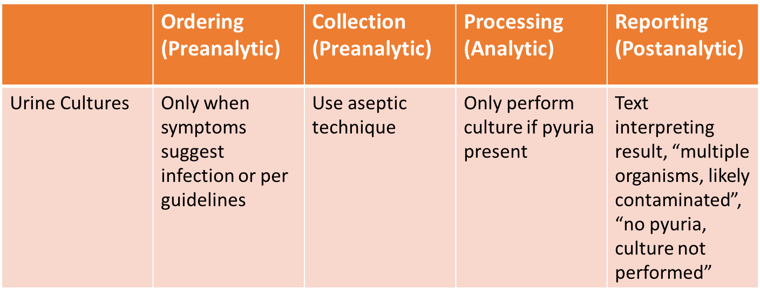

All urine testing should be done based on the clinical context, but when to test is often unclear for clinicians. In a survey of residents in an academic training program in Korea, ~70% of individuals decided to treat scenario patients with ASB. This lack of understanding translated into action, with many patients with ASB receiving antibiotics on the wards that the residents worked on.

Available studies show that a negative UA (dipstick or other, defined as no LE or nitrites) has excellent negative predictive for a negative culture. In one study of elderly inpatients, a negative UA could have eliminated ~40% of urine cultures. Given the delay in waiting for culture results, this intervention could impact time on empiric antibiotics. The converse case, a positive UA, is not a strong predictor for positive urine cultures. These data are important when thinking about reflex culture programs – if a negative UA predicts a negative culture, those patients shouldn’t be on antibiotics regardless (caution in neutropenia).

Similar to above, if a urine culture is sent, the results should be followed up. In a study in pediatric patients treated for UTI in the ED, ~50% of patients had a negative culture. Two important points: the patient doesn’t have a UTI, so antibiotics should be stopped, and UTI may have been a “false diagnostic anchor” that means the real reason for coming to the ED may still be unaddressed.

On the cutting edge, one center decided to suppress culture results for inpatients without urinary catheters. The microbiology lab processed the specimens, but providers had to call the lab to get the results. This intervention led to a decrease of 87% in utilized cultures and a 75% decrease in ABS treatment in the study population.

Take-away: There are laboratory diagnostic interventions that can positively impact the diagnosis and mis-diagnosis of UTI. Lowest hanging fruit is likely provider education, but AS teams should consider how UAs and urine cultures are being used and how the data are being used.

**Case Discussions:**

80 year-old man found with persistent MRSA bacteremia x 6 days in setting of DVT but no evidence of endocarditis. Vancomycin MIC 1-2 by broth microdilution. Received 6 weeks of IV vancomycin for complicated MRSA bacteremia (followed by doxycycline). Experienced recurrence of MRSA bacteremia 4 months later (again, vanco MIC 1-2), now found with L spine osteomyelitis and received daptomycin.

**1) What is the significance of a vancomycin MIC of 2 for MRSA bacteremia?**

In a patient who is clinically improving, we do not recommend making a treatment change based on a vanco MIC value of 2 alone, due to the limitations of this testing modality and data showing no increased mortality in patients with MRSA bacteremia and vanco MIC of 1.5 or 29. And though 5 days of bacteremia makes us nervous about the possibility of treatment failure (and lack of source control), MRSA bacteremia has been shown to persist on average 8 days in studies of bacteremia with and without endocarditis10, and therefore may not necessitate the need for a treatment change.

**2) What makes MRSA bacteremia uncomplicated and therefore amenable to 2 weeks of treatment?**

Uncomplicated MRSA bacteremia meets the following criteria11:

-exclusion of endocarditis

-no implanted prostheses

-follow-up blood cultures performed on specimens obtained 2–4 days after the initial set that do not grow MRSA

-defervescence within 72 h of initiating effective therapy

-no evidence of metastatic sites of infection

**3) In hospitals without ready access to ID consults for Staph aureus bacteremia, what is the process?**

-For complicated *Staph aureus* bacteremia, some have access to ID consult recommendations from ID teams in Spokane and either transfer inpatients or receive recommendations and arrange for early outpatient ID follow-up.

**Thanks! The UW TASP Team**

**References:**

1. Humphries, R. M. & Dien Bard, J. Point-Counterpoint: Reflex Cultures Reduce Laboratory Workload and Improve Antimicrobial Stewardship in Patients Suspected of Having Urinary Tract Infections. *J. Clin. Microbiol.* **54**, 254–258 (2016).
2. Watson, J. R., Sánchez, P. J., Spencer, J. D., Cohen, D. M. & Hains, D. S. Urinary Tract Infection and Antimicrobial Stewardship in the Emergency Department. *Pediatr. Emerg. Care* **34**, 93–95 (2018).
3. Lee, M. J. *et al.* Why is asymptomatic bacteriuria overtreated?: A tertiary care institutional survey of resident physicians. *BMC Infect. Dis.* **15**, 289 (2015).
4. Shimoni, Z., Hermush, V., Glick, J. & Froom, P. No need for a urine culture in elderly hospitalized patients with a negative dipstick test result. *Eur. J. Clin. Microbiol. Infect. Dis.* **37**, 1459–1464 (2018).
5. Leis, J. A. *et al.* Reducing antimicrobial therapy for asymptomatic bacteriuria among noncatheterized inpatients: a proof-of-concept study. *Clin. Infect. Dis.* **58**, 980–983 (2014).
6. Nicolle, L. E. *et al.* Clinical Practice Guideline for the Management of Asymptomatic Bacteriuria: 2019 Update by the Infectious Diseases Society of America. *Clin. Infect. Dis.* (2019). doi:10.1093/cid/ciy1121
7. Morgan, D. J., Malani, P. & Diekema, D. J. Diagnostic Stewardship-Leveraging the Laboratory to Improve Antimicrobial Use. *JAMA* **318**, 607–608 (2017).
8. Power, M., Fell, G. & Wright, M. Principles for high-quality, high-value testing. *Evid. Based. Med.* **18**, 5–10 (2013).
9. Kalil AC, Van Schooneveld TC, Fey PD, Rupp ME. Association between vancomycin minimum inhibitory concentration and mortality among patients with Staphylococcus aureus bloodstream infections: a systematic review and meta-analysis. JAMA. 2014 Oct 15;312(15):1552-64.
10. Fowler Jr VG, *et al*. Daptomycin versus standard therapy for bacteremia and endocarditis caused by Staphylococcus aureus. New England Journal of Medicine. 2006 Aug 17;355(7):653-65.
11. Liu C, *et al*. Clinical practice guidelines by the Infectious Diseases Society of America for the treatment of methicillin-resistant Staphylococcus aureus infections in adults and children. Clinical infectious diseases. 2011 Feb 1;52(3):e18-55.