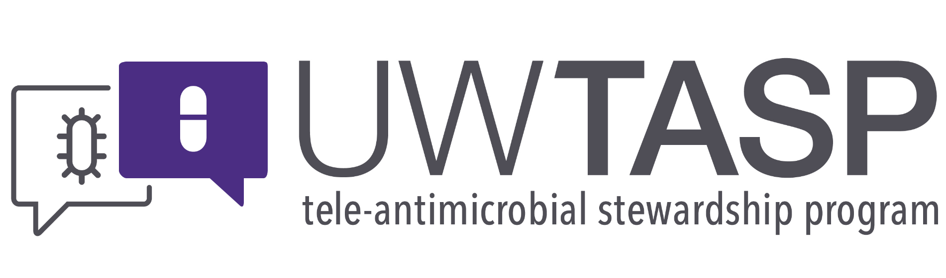

**Session Summary for 20 March 2018**

**Didactic: Anti-MRSA Drugs**

Speaker: Zahra Kassamali Escobar

Key points:

* Vancomycin is the main inpatient MRSA drug, as no other options have demonstrated clinical superiority and they are all more expensive
* Vancomycin dosing is complex
* Weight-based dosing (e.g. 15 mg/kg BID) is probably the right approach rather than fixed doses (e.g. 1000 mg BID)
* 2009 IDSA guidelines recommend monitoring troughs, but subsequent data do not support troughs as a measurement of efficacy
* PK/PD studies show that vancomycin AUC:MIC is the best indicator of effectiveness, troughs can still be utilized to assess toxicity
* Stewardship solutions to reduce the frequency of drug level monitoring can save time and money and improve the patient experience (less blood draws/dose changes).
* AUC monitoring calculators & Bayesian methods may be utilized for dose adjustments– but are limited by increased difficulty of use compared to trough measurements
* Linezolid may be superior for MRSA pneumonia and cost of PO tablets has come way down since introduction

Not talked about, but relevant: IV ceftaroline has equivalence data for MRSA (though should really be better!), good evidence for IV daptomycin for serious MRSA infections up to and including right sided endocarditis. Cost remains an issue for both drugs.

**Case Discussion**

Case 1 from Janet @ Forks

Pregnant women with a reported penicillin allergy and GBS infections. Recommended treatment for GBS is penicillin G, but due to allergy, these patients are usually given either clindamycin or vancomycin, both of which are likely to be inferior, associated with adverse effects and may be deleterious to the neonates microbiota development. There is also a reported 1 in 5,000 risk of an adverse reaction during PCN skin testing.

1. Regarding the safety of PCN skin testing in pregnant women

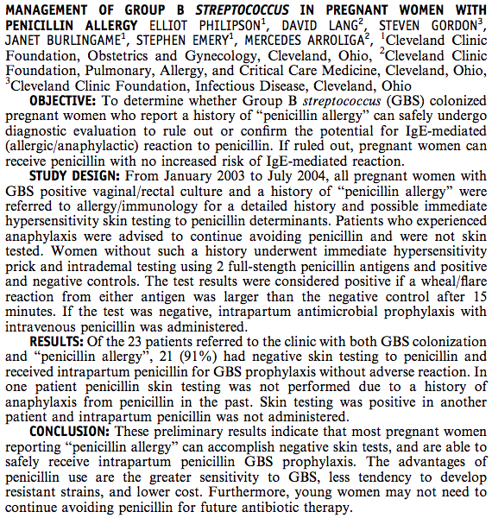

Philipson, E. *et al.* Management of Group B streptococcus in pregnant women with penicillin allergy. *Am. J. Obstet. Gynecol.* **191,** S57 (2004).

1. Outcomes in pregnant women with GBS and PCN allergy

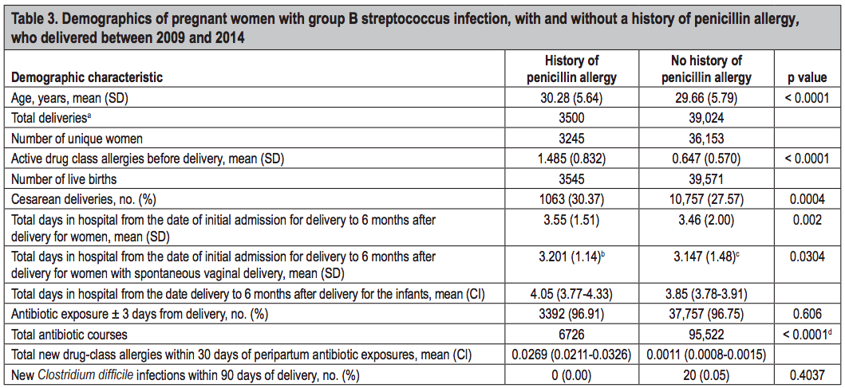

Desai, S. H., Kaplan, M. S., Chen, Q. & Macy, E. M. Morbidity in Pregnant Women Associated with Unverified Penicillin Allergies, Antibiotic Use, and Group B Streptococcus Infections. *Perm. J.* **21,** (2017).

1. For non-allergic pts, the most common antibiotic for GBS was PCN and the 2nd most common was cefazolin. For the reported allergic pts, the most common abx was clindamycin (58%) and, surprisingly, the 2nd most common abx was cefazolin (38%).
2. Assessment of PCN allergy should be done early in pregnancy. Many reported allergies can be eliminated based on history, some can be confirmed, and for the rest, PCN skin testing appears to be safe and should be completed well before treatment is or is not needed for GBS. Like other primary care patients, removing PCN allergy from a patient’s record has benefits beyond the immediate need.

Case 2 from Merilla @ Lincoln

Sputum cultures are often ordered but can be difficult to obtain. Nurse sometimes try but are unsuccessful leading to a delay in specimen collection and processing by the microbiology laboratory. So, are sputum cultures useful and is there a time limit (after starting abx) beyond which they do not provide useful data?

1. [IDSA/ATS guidelines for community acquired pneumonia](http://www.idsociety.org/Guidelines/Patient_Care/IDSA_Practice_Guidelines/Infections_By_Organ_System-81567/Lower/Upper_Respiratory/Community-Acquired_Pneumonia_(CAP)/) are unclear on the topic of sputum cultures. Sputum cultures can be helpful if the quality of the specimen is good, i.e. preferably before abx and not grossly contaminated with oral cells and bacteria. Unfortunately, many specimens are more saliva and epithelial cells than neutrophils and pathogenic bacteria. When there are lots of neutrophils and a predominance of a likely pathogen on smear (and later on culture), a sputum culture can be very helpful. The other opportunity with a sputum culture that finds something unexpected or not covered by the patient’s current coverage, such as MRSA or pseudomonas. This can support a change in abx regimen.
2. As for a deadline for obtaining a sputum for evaluation. The best bet is prior to antibiotics, but not definitive. Each abx class penetrates the alveolar spaces at a different rate, so challenging to predict when the antibiotic would start to have an effect, hence the rec for ASAP. Reviewed studies often use a 24 hour cut-off, so probably reasonable to use that time limit as a cut-off.
3. The clinical microbiology lab generally does not know about when antibiotics are administered so cannot reject specimens based on that time-line. They do use a scoring system for the proportion of epithelial cells to neutrophils that does allow them to reject inadequate specimens.
4. As an aside Tyler (and Patrick) mentioned a system that alerts RNs in the ED to obtain cultures prior to giving antimicrobials. The alert fires in the Pyxis. This is a fantastic intervention and hope to learn more.

Thanks everyone for another great session! See you next week, Team TASP.